Comparing Two Kinds of Communities

_____________ community ______________ community

(____________) (____________)

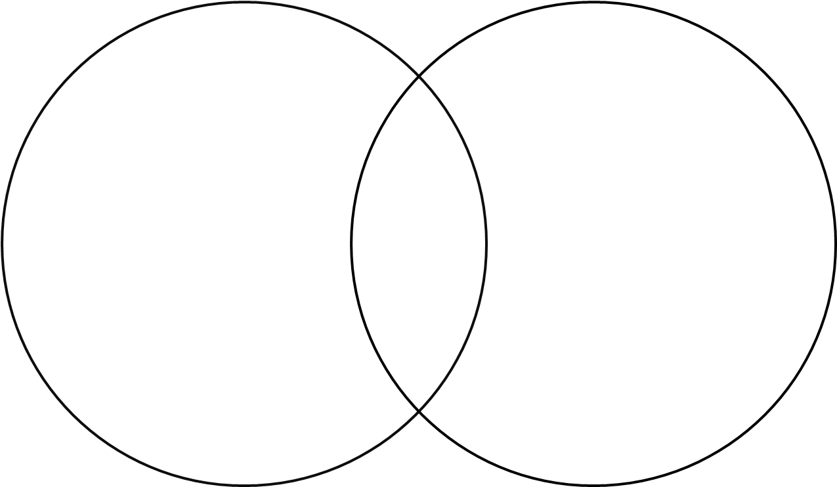

I would prefer to live in a __________________________ community

because _________________________________________________________

_________________________________________________________________

I have wants and needs.

Something I want is: | Something I need is:

Communities have needs.

People in an urban community need: | People in a rural community need:

