The Haudenosaunee: The Six Nations Confederacy

In the box below, draw a symbol that represents you:

Tell what the symbol is and why you chose it:

_____________________________________________________________________

_____________________________________________________________________

_____________________________________________________________________

_____________________________________________________________________

The symbols of the six nations

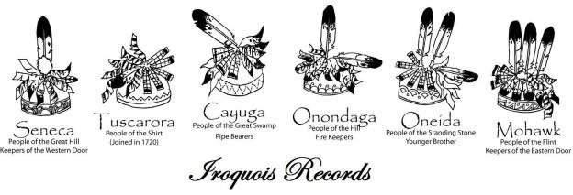

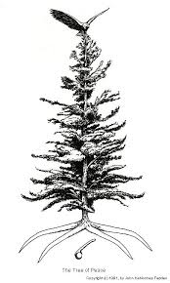
The Symbols of the Tree of Peace:

The eagle _____________________________

____________________________________

The branches __________________________

____________________________________

The roots _____________________________

____________________________________

The weapon ___________________________

____________________________________

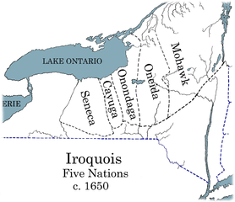

The Keepers of the Eastern Door were the
_____________________________

The Keepers of the Western Door were the
_____________________________

The Keepers of the Council Fire were the
____________________________

The “older brothers” were ______________________
and _______________________

The “younger brothers” were ______________,
_______________ and _______________

