The Haudenosaunee: People of the Longhouse

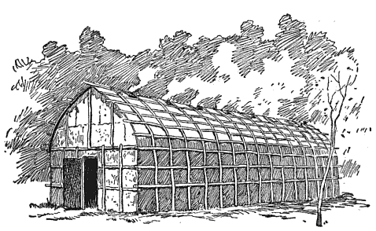

Use the following vocabulary words to fill in the blanks in the passage. Cross each word off as you use it.

smokeholes bark doors protection palisade crops curved longhouses football field sedentary fire windows village families

The Iroquois were farmers and so they were ________________. This means they lived in one place and did not move around a lot. Instead, they built their homes near streams so they could be near their fields of ____________. Several of their homes, called ____________________, were built together in one ________________. The village would be surrounded by a type of fence called a ______________ that was about 15 to 20 feet high. This offered _________________ from attacks.

A longhouse was built with upright poles and logs and had a ______________ roof. It was covered with _________. There were two ____________ but no ___________________! The roof had ________________ so the people could always keep their fires going to cook and stay warm. Many _____________ lived together in one longhouse. Each family had their own section. The two families across the aisle from each other would share one ____________. If they needed to make room for more families, they could add to the longhouse. Depending on how many families lived there, a longhouse could be 150 feet in length. That’s as long as half of a _____________________!

