Date Reviewed
March 2023

Course
Law Studies 12

Topic
Evolution of Law

Big Idea
Laws are interpreted, and these interpretations may evolve over time as a society’s values and worldviews change.

Essential Question
How have principles of law and justice changed over time and how do they differ today in different legal systems?

Learning Standards
Content:
Students are expected to know the following:
- Structures and powers of the federal and provincial courts and administrative tribunals
  - Case and common law

Curricular Competencies
Students are expected to be able to do the following:
- Assess and compare the significance and impact of legal systems or codes (significance)
- Assess the development and impact of legal systems or codes (cause and consequence)

Core Competencies
Communication – I can debate the merits of different legal systems by using persuasive language and examples.

Thinking – I can analyze early legal systems to identify key principles and commonalities.

Personal and Social – I can collaborate to construct a comprehensive argument.

First People’s Principles of Learning
- Learning is embedded in memory, history, and story.

Introduction
- Using a Think Pair Share strategy, pose the question: What is law and why do we have it? Provide students with time to reflect before discussing with a partner, and then sharing ideas as a class.
- Ask what would happen if we played hockey without rules (violence, disorder) or if there were no rules in school (chaos). After a short discussion, explain that when people form groups, they need to make rules to:
  - Keep people safe
  - Keep organized and achieve goals
- Point out that laws are similar to rules: the main difference is that they apply at all times to all people in society. Ask students to identify some “regular” life activities that relate to law (i.e., renting an apartment, getting married, attending a protest, etc.) Discuss as a class using the handout “How Law Connects to Life”.

Pre-Assessment
- Explain that while many early civilizations relied on local customs and beliefs, some laws were eventually written down, or codified. Students will compare the early history of laws.
- Provide students with the handout “Early Legal Systems”.
- Using a Jigsaw strategy, assign students to one of three groups:
- The Code of Hammurabi
- Mosaic Law
- Roman Law
- Have students research and make notes on their assigned legal system using the handout.
- Afterwards, have each student join two students who researched the other two early legal systems.
- Provide each triad with the handout “Comparing Early Legal Systems”. Students will discuss the principles and areas of laws covered in each to fill out the three circles.

Interactive Learning Activities
- Explain that two of the most common legal systems in the world are civil law and common law. In Canada, most of the country follows the common law system. However, Quebec has a civil law system based on the Napoleonic Code, and many First Peoples follow their own systems of justice.
- Provide students with access to What is the Difference Between Common Law and Civil Law? and Common and Civil Law Are Two Very Different Legal Systems (lawteacher.net)
- Ask students to record definitions for common law, case law, and civil law. Then discuss the following questions in pairs:
  - What is the principle of precedent?
  - Discuss the advantages and disadvantages of precedent.
  - Define common law in your own words.
  - How is statute law a source of law?
- Provide students with the chart “Common Law vs Civil Law” in order to identify the key differences in common law and civil law.

Post-Assessment
- Provide students with the handout “Debate: Common Law vs. Civil Law”.Introduce the debate topic: Be it resolved that common law is a superior justice system than civil law.
- Assign students to either the pro side or the con side. Explain the importance of collaboration when constructing their argument (research, main points) and rebuttals. Each group may choose to break down roles into researchers, organizers, speakers, etc.
- Assess debates using the “Debate Rubric”.

Extension Activities
- Provide students with the articles Medieval Trials Great and Gruesome and Law and Order in Medieval England.
- Have students prepare a pamphlet on one type of Medieval trial (i.e. trial by ordeal, trial by combat, etc.), explaining their purpose and legal justification.
- Students can present their findings to a Social Studies 8 classes studying the Middle Ages.

See for reference:

Medieval Trials, Great and Gruesome, law2.umkc.edu/faculty/projects/ftrials/Medievaltrials/medievalaccount.htm.

Neal, J. 2021. “Law & Order in Medieval England.” Harvard Law Today, 1 Mar. 2021, https://today.law.harvard.edu/law-order-in-medieval-england/

Additional References

Canada. 2017. “Where Our Legal System Comes From.” Canada's System of Justice. Ottawa: Department of Justice. https://www.justice.gc.ca/eng/csj-sjc/just/03.html

Cartwright, M. 2013. “Roman Law.” World History Encyclopedia. https://www.ancient.eu/Roman_Law/

“Code of Hammurabi.” 2018. Encyclopædia Britannica. , Encyclopædia Britannica, Inc. https://www.britannica.com/topic/Code-of-Hammurabi

“Code of Hammurabi.” 2020. History.com. A&E Television Networks. https://www.history.com/topics/ancient-history/hammurabi

"Common and Civil Law Are Two Very Different Legal Systems." 2013. LawTeacher.net. All Answers Ltd. https://www.lawteacher.net/free-law-essays/common-law/common-and-civil-law-are-two-very-different-legal-systems-common-law-essay.php?vref=1
Davison, C. 2017. “The Evolution of Canadian Law.” LawNow Magazine. Centre for Public Legal Education Alberta. http://www.lawnow.org/the-evolution-of-canadian-law/

“Guide to International and Foreign Law Research: Legal Systems.” LibGuides. University of South Carolina School of Law https://guides.law.sc.edu/c.php?g=315476&p=2108388

“Hebraic Law.” 1998. Encyclopædia Britannica. Encyclopædia Britannica, Inc. https://www.britannica.com/topic/Hebraic-law

“Law of Moses.” 2021. Wikipedia, Wikimedia Foundation. https://en.wikipedia.org/wiki/Law_of_Moses.

Millner, M.A., Rheinstein, M., Glendon, M.A. Carozza, P. et al. 2020. “Roman Law.” Encyclopedia Britannica. Encyclopædia Britannica, Inc. https://www.britannica.com/topic/Roman-law

Syam, P. 2014. “What Is the Difference Between Common Law and Civil Law?” School of Law. St. Louis, MO: Washington University. https://onlinelaw.wustl.edu/blog/common-law-vs-civil-law/

BOOK
Murphy, T.G. 2010. 6th edition. “All About Law: Exploring the Canadian Legal System.” Toronto, ON: Nelson Education.

Materials and Resources:

How Law Connects to Life

Attending a protest
- Charter of Rights and Freedoms - freedom of assembly
- Reasonable limits – rights can restricted if protest is violent or hateful

Renting an apartment
- Residential Tenancy Act
- Rights and responsibilities of both tenants and landlords
- Terms of tenancy agreement (length, payment, rules, etc.)
- Rules and guidelines around resolving disputes

Getting married
- B.C. Marriage Act
- Need to apply for marriage license
- Civil or religious ceremony; civil ceremonies must be performed by marriage commissioners
- Must legally register marriage

Driving a car
- Motor Vehicle Act
- Registration, licensing, and insurance requirements
- Outlines duty of drivers at accidents
- Rules for driving in situations (yellow light, signaling, passing, etc.)

Other

Early Legal Systems

Name of Legal System:

Background:

What areas of law were included?

How does the system work?

Main Principles:

Example:

References:

Cartwright, M. 2013. “Roman Law.” World History Encyclopedia. https://www.ancient.eu/Roman_Law/

“Code of Hammurabi.” 2018. Encyclopædia Britannica. , Encyclopædia Britannica, Inc. https://www.britannica.com/topic/Code-of-Hammurabi

“Code of Hammurabi.” 2020. History.com. A&E Television Networks. https://www.history.com/topics/ancient-history/hammurabi

“Hebraic Law.” 1998. Encyclopædia Britannica. Encyclopædia Britannica, Inc. https://www.britannica.com/topic/Hebraic-law

Kiralfy, A.R., Rheinstein, M., Carozza, P., Jolowicz, H.F., et al. 2020. Roman law. Encyclopedia Britannica. https://www.britannica.com/topic/Roman-law

“Law of Moses.” 2021. Wikipedia, Wikimedia Foundation. https://en.wikipedia.org/wiki/Law_of_Moses.

Murphy, T.G. 2010. 6th edition. “All About Law: Exploring the Canadian Legal System.” Toronto, ON: Nelson Education.
Answer Key: Code of Hammurabi

Name of Legal System: Code of Hammurabi

Background:
- One of earliest written legal codes
- Hammurabi was a king in Babylon (1792 to 1750 B.C., present-day Iraq)
- The code (laws) was carved into stone

What areas of law were included?
- Commercial interactions - i.e., contracts, prices, tariffs, trade, commerce
- Administrative law
- Family law - i.e., marriage and divorce
- Criminal law - i.e., assault, theft
- Civil law - i.e., slavery, debt

How does the system work?
- Collection of 282 rules
- Standards for commercial issues
- Fines and punishments for justice
- Accused person was considered innocent until proven guilty
- If- then phrasing (“if a man steals an
ox, then he must pay back 30 times its value)
- Different standards for the three social classes of Babylonian society
  - i.e., “Penalties for malpractice followed the same scheme: a doctor who killed a rich patient would have his hands cut off, while only financial restitution was required if the victim was a slave.”

Main Principles:
- Retribution (an eye for an eye)

Example:
- “If a man breaks down a wall of a house in an attempt to rob it (quite literally "breaking into") and is caught, his punishment will be to become sealed up inside the wall as a patch.”

References:

“Code of Hammurabi.” 2018. Encyclopædia Britannica. , Encyclopædia Britannica, Inc. https://www.britannica.com/topic/Code-of-Hammurabi

“Code of Hammurabi.” 2020. History.com. A&E Television Networks. https://www.history.com/topics/ancient-history/hammurabi

Answer Hey: Hebraic Law Worksheet

Name of Legal System: Hebraic Law, also called Mosaic Law

Background:
- refers to ancient Hebrew codes of law
- found in different parts of the Old Testament of the Bible
- unique compared to other early laws, as offenses were seen as offences not only as contravening society, but as offences against God

What areas of law are included?
- The Ten Commandments
- Food laws (clean and unclean food)
- Criminal law - i.e., murder, theft, adultery (with a focus on morality)
- Family law - i.e., marriage and divorce
- Civil law - i.e., property, inheritance
- Religious standards - for priesthood, offerings, the Tabernacle

How does the system work?
- Laws are laid out throughout five books of the Bible
- This includes religious instructions and standards
- ”If-then” case laws lay out a situation and the punishment to follow; punishments are typically severe

Main Principles:
- Severe Punishments
- Restitution - i.e., repaying a victim for stolen goods

Example:
“Whoever strikes his father or mother shall be put to death.”

References:

“Hebraic Law.” 1998. Encyclopædia Britannica. Encyclopædia Britannica, Inc. https://www.britannica.com/topic/Hebraic-law

“Law of Moses.” 2021. Wikipedia, Wikimedia Foundation. https://en.wikipedia.org/wiki/Law_of_Moses.

Murphy, T.G. 2010. 6th edition. “All About Law: Exploring the Canadian Legal System.” Toronto, ON: Nelson Education.

Answer Key: Roman Law Worksheet

Name of Legal System: Roman Law

Background:
- Corpus Juris Civilis (body of civil law) - this piece of legislation by emperor Justinian I is one of most important sources of Roman Law
- This system developed in 753 BCE and remained in use in the Byzantine Empire until 1453
- Two main reference works - collections of past laws, and opinions of Roman legal experts
- Is the basis for the law codes of most European countries today

What areas of law are included?
- Family- marriage, guardianship
- Contracts - land and property ownership, liability, and damage, rents, leases
- Law of succession
- Procedure laws - for lawsuits and complaints
- Criminal law
- Commerce laws for specific industries
- Citizenship

How does the system work?
- Law established through statutes as well as decisions by officials, rulers, and assembly votes
- Flexible and cumulative in nature - new laws could be added or replace old laws
- During the Republic, law could be adapted by magistrates (i.e., increase a fine to keep pace with inflation)
- Emperors and the Senate could issue pronouncements
- Legal experts called jurists examined laws to find legal principles that could be applied to new legislation
- Penalties for crimes could include loss of citizenship, fines, prisons, forced labour, etc. Males of higher social status usually received lesser penalties.

Main Principles:
- Fairness and practicality
- Penalties for crimes as deterrents rather than punishments

Example:

“The child born to you and your wife is in your power. And so is the child born to your son of his wife, that is, your grandson or granddaughter; so are your great-grandchildren, and all your other descendants. But a child born of your daughter is not in your power, but in the power of its own father.”

References:
Cartwright, M. 2013. “Roman Law.” World History Encyclopedia. https://www.ancient.eu/Roman_Law/

Millner, M.A., Rheinstein, M., Glendon, M.A. Carozza, P. et al. 2020. “Roman Law.” Encyclopedia Britannica. Encyclopædia Britannica, Inc. https://www.britannica.com/topic/Roman-law

Comparing Early Legal Systems

Instructions: Discuss the similarities and differences of the legal systems.

Answer Key: Comparing Early Legal Systems

Instructions: Discuss the similarities and differences of the legal systems.

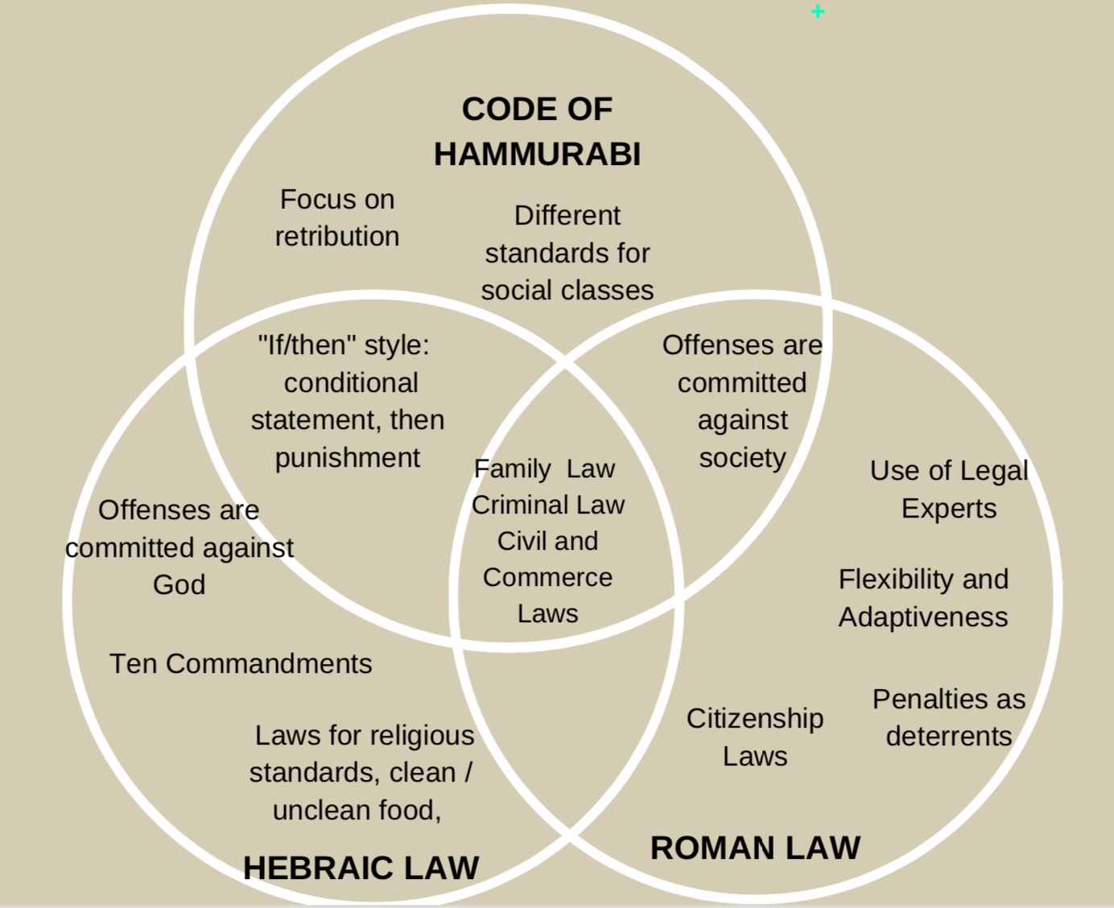

Common Law vs. Civil Law

Common Law | Civil Law

References:

Common and Civil Law Are Two Very Different Legal Systems." 2013. LawTeacher.net. All Answers Ltd. https://www.lawteacher.net/free-law-essays/common-law/common-and-civil-law-are-two-very-different-legal-systems-common-law-essay.php?vref=1

Syam, P. 2014. “What Is the Difference Between Common Law and Civil Law?” School of Law. St. Louis, MO: Washington University. https://onlinelaw.wustl.edu/blog/common-law-vs-civil-law/

Answer Key: Common Law vs. Civil Law

Common Law | Civil Law
-based on the concept of precedent  -judges have an active role shaping the law- their decisions become precedent for future cases  -laws created by legislators but judges interpret laws and precedent for individual cases  -lawyers have key role in argument and in-court presentations  -judge as “referee”  -origin in UK - prior to 1066, “customs”  - William the Conqueror united customs in “common” law for the country  -decisions of courts recorded and published -stare decisis - “let the decision stand”  -codified laws exist as statutes | -emphasis is on codification of law - written statutes  -codes, or statutes, establish legal procedures and punishments  -these codes are updated regularly  -lawyers have less central role- focus on advising clients on points of law  -judge’s role is to establish facts of case and apply the law  - judge as “investigator”  -less influence over legal system than  lawmakers, scholars, and legal experts  -origin from Roman Law  -legal systems are entirely codified

Reference:

Common and Civil Law Are Two Very Different Legal Systems." 2013. LawTeacher.net. All Answers Ltd. https://www.lawteacher.net/free-law-essays/common-law/common-and-civil-law-are-two-very-different-legal-systems-common-law-essay.php?vref=1

Syam, P. 2014. “What Is the Difference Between Common Law and Civil Law?” School of Law. St. Louis, MO: Washington University. https://onlinelaw.wustl.edu/blog/common-law-vs-civil-law/

Debate: Common Law vs. Civil Law
Be it resolved that:

The common law system is a superior justice system than the civil law system.

Side:____

You will either be arguing on the Pro side (in favour of the resolution), or the Con side (against the resolution). Either way, you will have to work with your group to divide up the roles (opening, arguments, rebuttal, and conclusion). Within these roles, work together to present cohesive arguments and rebuttals. Start by considering specific facts, philosophical arguments, and cases studies that can support your side.

Opening Statement  (1 person) | Hook:  Position on Resolution:  Brief Summary of Main Points:
Main Arguments  (6 people) | Why is your side right?  1st Point:  2nd Point:  3rd Point:  4rd point:
Rebuttal  (6 people) | Think: If you were on the other side, what arguments would you make? | Why are these arguments wrong?
Conclusion  (2 people) | Summary of your side’s arguments:  Summary of other side’s arguments:  Summary of rebuttals and conclusion:

Evaluation is based on:
- Individual notes and sources (your contributions to the group’s argument)
- Performance in the debate
Debate Rubric

 | Minimally Meeting Expectations | Approaching Expectations | Meeting Expectations | Exceeding Expectations
Critical Thinking and Understanding  Research notes and sources | -limited inclusion of statistics or case studies to support arguments and rebuttals  -minimal reliable sources referenced  -limited  analysis of information to prepare arguments and rebuttals | -includes some statistics or case studies to support arguments and rebuttals  -some reliable sources referenced  -some  analysis of information to prepare arguments and rebuttals | -includes statistics and case studies to support arguments and rebuttals  -references reliable sources  -adequately analyzes and interprets the information to prepare arguments and rebuttals | -includes a variety of statistics and case studies to support arguments and rebuttals  -references a variety of reliable sources  -analyzes and interprets the information insightful ways to prepare arguments and rebuttals
Communication and Persuasive Techniques  Debate performance | -expresses ideas through unconvincing or limited arguments  -makes arguments and rebuttals in an unconvincing way  -minimal use of gestures and eye contact | -expresses ideas with some sense of argument  -makes arguments and rebuttals in an adequately convincing way  -makes some use of gestures and eye contact | -expresses ideas with a sense of logical argument  -makes arguments and rebuttals in a convincing way  -uses gestures and eye contact effectively | -expresses ideas with a sophisticated sense of logical argument  -makes arguments and rebuttals in a persuasive and highly convincing way  -uses gestures and eye contact skillfully to enhance communication

