Date Reviewed
February 2023

Course
Social Studies 9

Topic
Komagata Maru Incident

Big Idea
Disparities in power alter the balance of relationships between individuals and between societies.

Essential Question
• How do a country’s laws and policies reflect its values?

Learning Standards
Content:
Students are expected to know the following:
- discriminatory policies, attitudes, and historical wrongs

Curricular Competencies
Students are expected to be able to do the following:
- Assess the significance of people, places, events, or developments, and compare varying perspectives on their historical significance at particular times and places, and from group to group (significance)
- Make reasoned ethical judgments about actions in the past and present, and determine appropriate ways to remember and respond (ethical judgement)

Core Competencies
Communication – I can summarize how Canadian immigration policies have changed over time.

Thinking – I can explain the importance of the Komagata Maru Incident and its significance in Canadian history

Personal and Social - I can consider how our laws and policies reflect our values.

First People’s Principles of Learning
Learning involves recognizing the consequences of one’s actions.

Introduction
- Show the short CBC news video, Remembering the Kamagata Maru (2:37)
- Ask: Had you heard about the Kamagata Maru incident before? Why is it important for Canadians to remember this incident that happened over 100 years ago?

Pre-Assessment
Think Pair Share
- What do you know about the Kamagata Maru incident?
- What do you wonder about this incident?

Interactive Learning Activities
Part 1: Background
- Show the Canadian Museum of Immigration at Pier One’s short video Komagata Maru (2:32). [If video will not play, read the transcript instead.]
- Have students take notes using the Komagata Maru 5 W Pyramid sheet.
- Show the short video from South Asian Stories - Episode 3 - Komagata Maru: Laws of Exclusion. (5:35)
- Have students add more details to the Komagata Maru 5 W Pyramid sheet.

Part 2: Evidence
- Have students read the article The Incident and examine the accompanying primary source evidence from the SFU library.
- Put students in 9 groups and assign each group one of the primary sources.
- Have each group complete a Primary Source Analysis.
- Have a spokesperson for each group report their findings to the class.

Part 3: Perspective
- Read aloud The Story of the Kamagata Maru.
- Have students explore the Passenger List of the Kamagata Maru and select one passenger that interests them.
- Have students write a letter to Prime Minister Robert Borden from the perspective of the passenger that they selected.
- Students can use the Letter Planner to organize their writing.

Part 4: Significance
- Have students read South Asians in Canada Before the Komagata Maru
- Discuss:
- What laws did the Canadian government make to prevent immigrants from India from coming to Canada? (Continuous Journey Act of 1908 and Immigration Act of 1910 which required South Asians to have $200)
- How did these laws prevent South Asian from entering Canada? (At that time, it was impossible to book direct travel from India to Canada and $200 was a large sum of money.)

- Why does it matter that both India and Canada were part of the British Empire? (It should have been easy to immigrate from one part of the British Empire to another. Indians had rights as British subjects which should have carried over to Canada.)
- How did Canada’s immigration laws at the time of the Komagata Maru Incident reflect Canadian values? (White Canadians wanted Canada to be a white country.)

Part 4: Continuity and Change
- Have students work together to create a timeline of the past 150 years of immigration policies and laws in Canada.
- Assign each student of pair of students one of Canadian Immigration Acts and Legislation.
- Students should include words and images to represent their assigned piece of legislation.
- Place the policies and immigration in chronological order on a bulletin board to create a timeline. Add the title “150 Years of Canadian Immigration Policies and Laws”
- Have each student examine the timeline and then come up with a word, phrase, or sentence to describe how Canada’s immigration policy has evolved.
- Use a strategy to discuss “What differences exist between our ideas of right and wrong in today’s society compared to those that existed in the past 100 years on the topics of immigration and race?”
Part 5: Ethical Judgement
- Show the CTV News video Why the Apology Matters More than a Century Later (1:49)
- Ask “How does apologizing about an incident that occurred before any of us were born serve a useful social purpose?”
- Have students work in small groups to complete the chart Apologizing for Historic Injustices. Encourage students to consider the concepts of fairness, meaningfulness, and responsibility.

Post-Assessment
- Have students respond to the following questions in their journals:
- How have Canada’s immigration policies changed over the years?
- Why is it important for governments to address historic wrongs?
- How does remembering the Komagata Maru impact our attitudes toward present day events?

Extension Activities
- Students can work in groups to create a Public Service Announcement about an injustice committed by the Canadian governments of the late 19th and early 20th centuries.

Additional References

Websites

Buchignani, Norman; Jacobsh, Doris R. 2020. “Sikhism in Canada.” The Canadian Encyclopedia.
https://thecanadianencyclopedia.ca/en/article/sikhism
A detailed summary of Sikh’s immigration and adaptation to Canada

Buchignani, Norman; Cooper, Celine. 2020. “South Asian Canadians.” The Canadian Encyclopedia.
https://www.thecanadianencyclopedia.ca/en/article/south-asians

Canada. 2016. “Komagata Maru apology in the House of Common.” House of Commons. Speeches.
https://pm.gc.ca/en/news/speeches/2016/05/18/komagata-maru-apology-house-commons

Canada. 2016. “The Komagata Maru Incident of 1914.” https://www.canada.ca/en/parks-canada/news/2016/08/the-komagata-maru-incident-of-1914.html

Canadian Children’s Book Centre’s. [n.d.] “List of Canadian Immigration Books for Kids and Teens.”
https://www.bookcentre.ca/files/ImmigrationBookList.pdf

Johnston, Hugh. “Komagata Maru.” 2016. The Canadian Encyclopedia.
https://www.thecanadianencyclopedia.ca/en/article/komagata-maru

McRae, Matthew. [n.d.] The Story of the Komagata Maru.” Canadian Museum for Human Rights.
https://humanrights.ca/story/the-story-of-the-komagata-maru

Palmer, Howard, et al. 2015. “Prejudice and Discrimination in Canada.” The Canadian Encyclopedia. https://www.thecanadianencyclopedia.ca/en/article/prejudice-and-discrimination

Raska, Jan. [2020?] “Who is Admissible?” Canadian Museum of Immigration at Pier 21. https://pier21.ca/blog/jan-raska/who-is-admissible

Royal B.C. Museum. [n.d.] “Lesson: The Punjabi Experience in British Columbia.” Learning Portal.
https://learning.royalbcmuseum.bc.ca/wp-content/uploads/2016/06/Elementary-School-lesson-plan.pdf

Sikhs.org. 2011. “Century of Struggle and Sucess. [sic] The Sikh Canadian Experience.” http://www.sikhs.org/100th/
This website celebrates the 100 years of Sikhs in Canada (1897-1997) and gives a detailed history of their experience.

Van Dyk, Lindsay. [2020?] “Canadian Immigration Acts and Legislation.” Canadian Museum of Immigration at Pier 21.
https://pier21.ca/research/immigration-history/canadian-immigration-acts-and-legislation

Books

Chattopadhyay, Suchetana. Voices of Komagata Maru: Imperial Surveillance and Workers from Punjab in Bengal. New Delhi: Tulika Books, 2018.

Hickman, Pamela. Righting Canada’s Wrongs: The Komagata Maru and Canada’s Anti-Indian Immigration Policies in the Twentieth Century. Toronto: James Lorimer & Company Ltd, 2014.

Kelkar, Supriya. “American as Paneer Pie.” New York : Aladdin, [2020]
-An Indian American girl navigates prejudice in her small town and learns the power of her own voice

Mawani, Renisa. Across Oceans of Law: The Komagata Maru and Jurisdiction in the Time of Empire. Durham: Duke University Press, 2018.

Materials and Resources (see next pages)

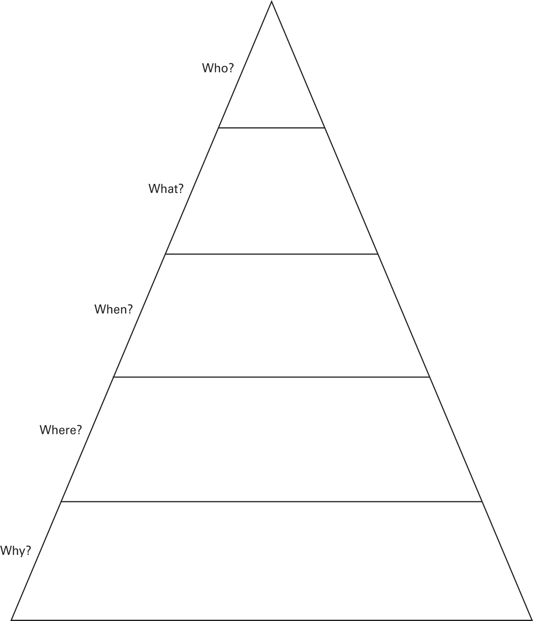
Komagata Maru Incident 5 W Pyramid

Letter Planner

Who are you? What is your name, gender, and age?

What skills and experience do you have?

What are your plans for employment in Canada?

Where do you want to live in Canada?

Why do you want to immigrate to Canada?

Apologizing for Historic Injustices

Benefits | Problems

