UNESCO1,726,556 followers
1yr • 1 year ago

Always dare to dream high, because careers have no gender! Period.
#WomenInScience
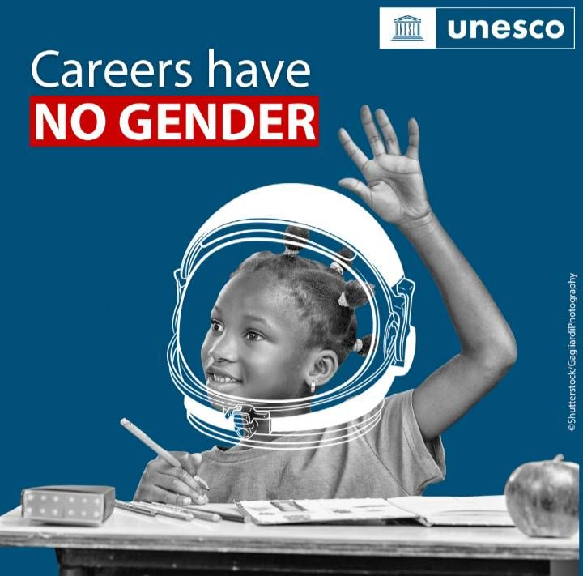
Activate to view larger image,
https://www.facebook.com/watch/?v=404983384931978 Accessed 14 February 2023
[static image of a girl]

