Careers have no gender – UNESCO (0.07 secs.)
https://www.facebook.com/watch/?v=449358290330267 Accessed 14 February 2023.

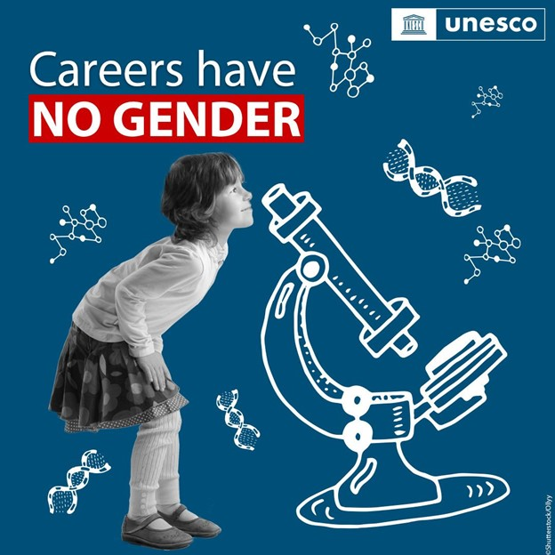

Gender equality and education | UNESCO
https://www.unesco.org/en/gender-equality/education Accessed 14 February 2023

