Date Reviewed
December 2020

Course
Law Studies 12

Topic
The Appeals Process

Big Idea
Laws are interpreted and these interpretations may evolve over time as a society's values and worldviews change.

Essential Question
How are appeals determined and how can appeals lead to changes in precedent?

Learning Standards
Content:
Students are expected to know the following:
- Structures and powers of the federal and provincial courts and administrative tribunals

Curricular Competencies
Students are expected to be able to do the following:
- Assess the justification for differing legal perspectives after investigating points of contention, reliability of sources, and adequacy of evidence (evidence)

Core Competencies
Communication
I can communicate and collaborate with my peers to review the process of appeals in Supreme Court of Canada cases.

Thinking
I can critically analyze Supreme Court decisions and identify their implications for the Canadian public.

Personal and Social
I can take responsibility for my role in researching and sharing information to my group.

First People’s Principles of Learning
Learning involves patience and time.

Introduction
- Pose the question: If a person believes that the judge came to a wrong decision in a case what can they do?
- Write the word “appeal” on the board. Activate prior knowledge by asking students to define the word. Then, ask students if they know what the appeals process is or how the word “appeal” relates to law.
- Show The British Columbia Court of Appeal video (7:45)

Pre-Assessment
- Have students respond to the following questions:
  - Who can appeal their case and why?
    - In criminal cases
    - In civil cases
  - What are some differences between appeal court and trial court?
    - No witnesses
    - Not “triers of fact”

Interactive Learning Activities
Part 1: Courts of Appeal
- Review the structure of Canada’s Court System. Hand out the “Canada’s Court System: Graphic Organizer” and project the Outline of Canada’s Court System. Students can use this to fill in their graphic organizer.
- Introduce the essential question: “How are appeals determined and how can appeals lead to changes in precedent?”
- Handout “The Appeal Process: Cloze Notes”. Use “The Appeal Process: Lecture Notes” to explain the process of appeal and provide students with definitions of key terms.
- After students have completed their notes, explain that they are going to look at Supreme Court cases to see examples of how the appeals process works.
- Provide students access to the Supreme Court of Canada’s Cases in Brief. These are reader-friendly summaries of recent cases.
- Handout the chart “Supreme Court of Canada Cases”. Model the process of filling out the worksheet with the class. You can use “Civil Example - Canada Post Corp. v. Canadian Union” and “Criminal Example - R. v. Chung”.

Part 2: Case Study Jigsaw
- Divide students into three groups. Assign each group one of the past three years. Each group will choose one civil and one criminal case from their assigned year.
- Provide each student with two more copies of the chart “Supreme Court of Canada Cases” and have them review their selected civil and criminal cases.
- Afterwards, have students from each of the three groups join together to form triads. Each student will represent one of the years, so each student will have different cases to share. Students will take turns presenting their two case reviews to the others in their triad.
- After each of the three students has shared, they should discuss the following questions in their triad:
- Why did most of these cases end up in the Supreme Court? (question of law or question of fact?)
- Was it common for the Supreme Court to come to a different decision than lower courts? Why or why not?
- Did these cases set a future precedent by clarifying an issue of law? Or was the decision specific to this particular case?
- Do you agree or disagree with any of these decisions? Why? If you disagree, why do you think the Court came to their conclusion?

Post-Assessment
- Provide students with “Assignment: Supreme Court Case Analysis”.
- In this formal written analysis, students will expand on the previous case studies to perform a full in-depth analysis of a Supreme Court of Canada case, with an overview of:
- Facts of the Case
- Issue (What questions of law was the court being asked to answer?)
- Appeals Process (What happened at previous levels of court?)
- Supreme Court Decision
- Significance of the Case and Decision
- Assess using “Rubric: Supreme Court Case Analysis”.

Extension Activities
- Have students investigate the process of appeal in an inquisitorial legal system and create a T-chart comparing appeals in the two systems.

Additional References
“British Columbia Court of Appeal.” YouTube, Justice Education Society of BC, 2 June 2009, www.youtube.com/watch?v=z0YgLOPrPJ8.
“Cases in Brief.” Supreme Court of Canada, Supreme Court of Canada, 18 Dec. 2020, www.scc-csc.ca/case-dossier/cb/index-eng.aspx.
“Courts of BC - Provincial Court.” YouTube, Justice Education Society of BC, 21 June 2012, www.youtube.com/watch?v=JI3Ax30Rols.
“Courts of BC - Supreme Court.” YouTube, Justice Education of Society of BC, 21 June 2012, www.youtube.com/watch?v=K_ATJJSGuhk.
Government of Canada, 16 Oct. 2017, www.justice.gc.ca/eng/csj-sjc/just/07.html.
Murphy, Terry, et. al. All About Law: Exploring the Canadian Legal System, 6th ed., Nelson Canada, 2009.
“The Judicial Structure.” Department of Justice, “The Appeal Process in Canada.” Department of Justice, Government of Canada, 10 Mar. 2017, www.justice.gc.ca/eng/csj-sjc/just/appeal-appel.html.

Materials and Resources

Canada’s Court System: Graphic Organizer

Instructions:

Fill out this graphic organizer of Canada’s Court System to increase your knowledge and understanding of the appeals process.

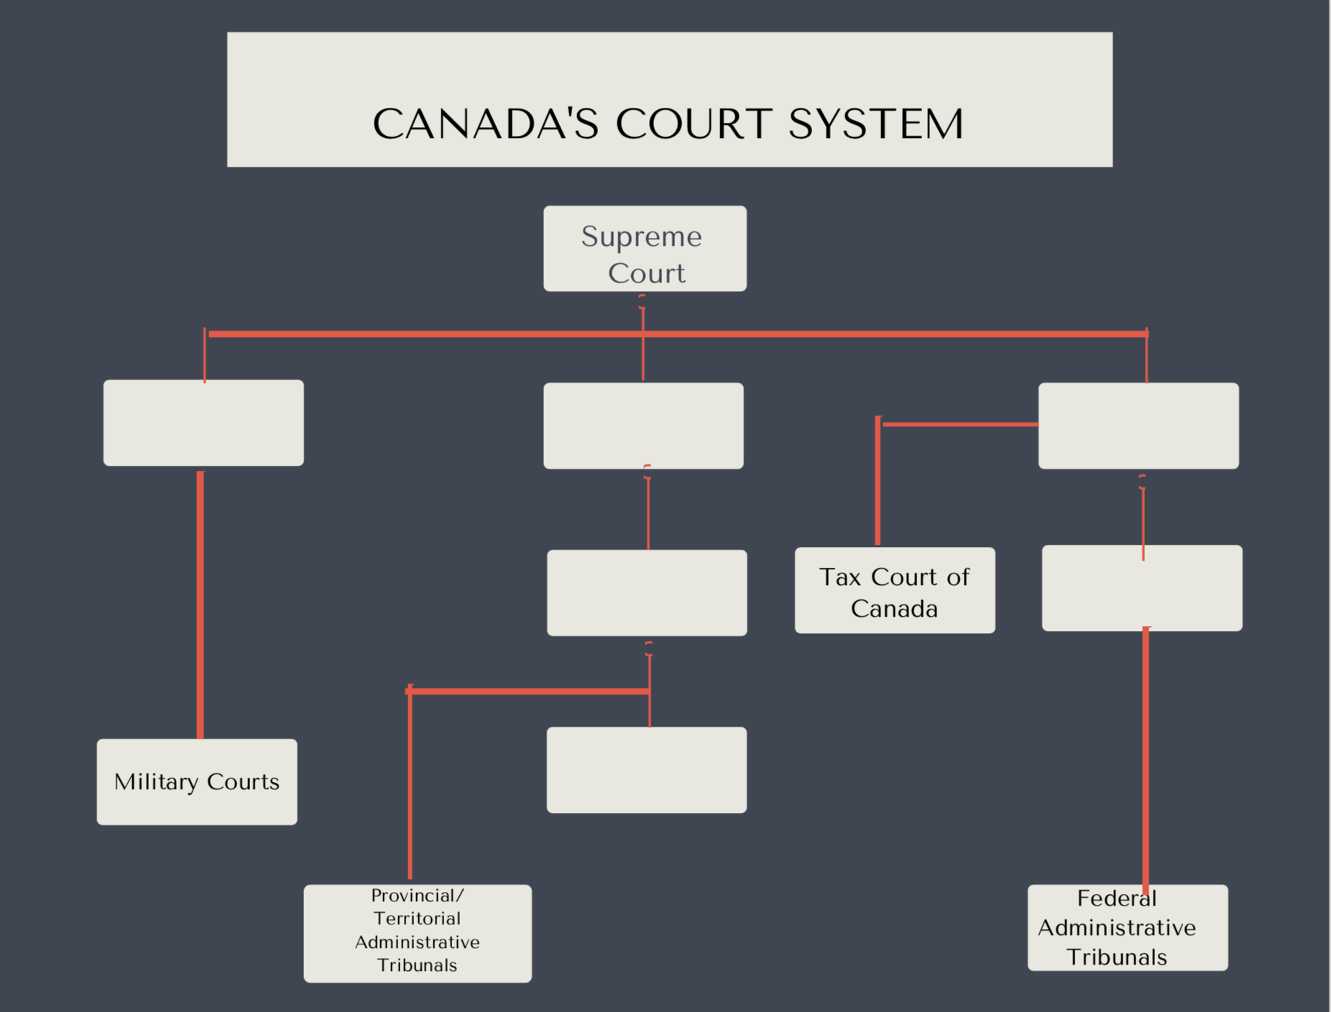

The Appeal Process: Cloze Notes

Most cases take place in ___________________ courts. The ______________ Court hears cases that involve federal law (includes constitutional challenges and Charter cases). It also can review the decision of ______________.

An ______________ is when there is an application to a ______________ court (Provincial/Territorial or Federal Courts of Appeal) to review the decision of a ______________ court. This applies to both ______________ and ______________ cases. In criminal cases, both the Crown and the defense have the right to request an appeal.

The ______________ is the party making the request for an appeal, while the ______________ is the party responding to (arguing against) the appeal.

Grounds or reasons for an appeal are:
- A question of ______________(how it was interpreted by the judge)
- A question of ______________ (i.e. whether evidence was relevant or credible)

New evidence is admitted in an appeal only if
- It is relevant and credible
- It would have affected______________
- Example: DNA evidence in a murder trial

Appeal Results:
- ______________ of previous judge’s decision
- ______________ or hearing

If an appeal from a Court of Appeal is not accepted by a party, they can ask the ____________________________to hear the case. If it does not hear the case, the decision of the court of appeal is ______________.
The Supreme Court of Canada is the___________________________ and lower courts of appeal must ______________ made by the higher courts.

Supreme Court Appeal Results:
- Reverse or change of previous judge’s decision
- ____________________________
- Order new trial or hearing

References:

Murphy, Terry, et. al. All About Law: Exploring the Canadian Legal System, 6th ed., Nelson Canada, 2009.

“The Judicial Structure.” Department of Justice, “The Appeal Process in Canada.” Department of Justice, Government of Canada, 10 Mar. 2017, www.justice.gc.ca/eng/csj-sjc/just/appeal-appel.html.

The Appeal Process: Lecture Notes

Most cases take place in provincial or territorial courts. The Federal Court hears cases that involve federal law (includes constitutional challenges and Charter cases). It also can review the decision of tribunals.

An appeal is when there is an application to a higher court (Provincial/Territorial or Federal Courts of Appeal) to review the decision of a lower court. This applies to both criminal and civil cases. In criminal cases, both the Crown and the defense have the right to request an appeal.

The appellant is the party making the request for an appeal, while the respondent is the party responding to (arguing against) the appeal.

Grounds or reasons for an appeal are:
- A question of law (how it was interpreted by the judge)
- A question of fact (i.e. whether evidence was relevant or credible)

New evidence is admitted in an appeal only if
- It is relevant and credible
- It would have affected the result of the trial
- Example: DNA evidence in a murder trial

Appeal Results:
- Reverse or change of previous judge’s decision
- Order new trial or hearing

If an appeal from a Court of Appeal is not accepted by a party, they can ask the Supreme Court of Canada to hear the case. If it does not hear the case, the decision of the court of appeal is final.

The Supreme Court of Canada is the final court of appeal and lower courts of appeal must follow the decisions made by the higher courts.

Supreme Court Appeal Results:
- Reverse or change of previous judge’s decision
- Agree with the previous decision
- Order new trial or hearing

References:

Murphy, Terry, et. al. All About Law: Exploring the Canadian Legal System, 6th ed., Nelson Canada, 2009.

“The Judicial Structure.” Department of Justice, “The Appeal Process in Canada.” Department of Justice, Government of Canada, 10 Mar. 2017, www.justice.gc.ca/eng/csj-sjc/just/appeal-appel.html

Supreme Court of Canada Cases

Instructions: Navigate to the Cases in Brief summaries of the Supreme Court of Canada’s recent decisions. Choose one civil and one criminal case to review and fill out the chart below to enhance your understanding of the appeals process.

URL: https://www.scc-csc.ca/case-dossier/cb/index-eng.aspx

Case Name
URL
Appellant in Case
Respondent in Case
Facts of Case
Issue
Appeal Process

(list decisions at different levels of court)
Decision at Supreme Court and Reasoning
Impact and Explanation

Supreme Court of Canada Cases
Civil Example - Canada Post Corp. v. Canadian Union of Postal Workers

Instructions: Navigate to the “Cases in Brief” summaries of the Supreme Court of Canada’s recent decisions. Choose one civil and one criminal case to review and fill out the chart below to enhance your understanding of the appeals process.

URL: https://www.scc-csc.ca/case-dossier/cb/index-eng.aspx

Case Name | Canada Post Corp. v. Canadian Union of Postal Workers
URL | https://www.scc-csc.ca/case-dossier/cb/2019/37787-eng.aspx
Appellant in Case | Canadian Union of Postal Workers
Respondent in Case | Canada Post Corporation
Facts of Case | The union filed a complaint in 2012 about a mail depot in Burlington, Ontario. The complaint referenced the Canada Labour Code and its requirement that a committee to inspect each part of a workplace for dangers to workers’ health and safety at least once a year.  The union said the Burlington committee was not inspecting each part of the workplace (which the union said included all mail routes and places it was delivered) at least once a year.
Issue | Does the workplace include mail routes and places it was delivered?  The union argued that the definition of workplace as it applied to Canada Post included all mail routes and places of delivery.
Appeal Process  (list decisions at different levels of court) | 1 - Health and Safety Officer agreed with Union  2 - Appeals Officers at Occupational Health and Safety Tribunal agreed with Canada Post  3 - Judicial Review at Federal Court agreed with Appeals Officers and Canada Post  4 - Federal Court of Appeal said Appeals Officers made mistakes; Court in favour of union - Canada Post had to inspect all routes and places of delivery  5 - Case goes to Supreme Court
Decision at Supreme Court and Reasoning | Majority of judges in favour of Canada Post Corp.  Some parts of the Code applied to all places of work, while others applied to places controlled by the employer. The part about inspections applied only to places controlled by the employer - therefore only those places had to be inspected once a year.  The reasoning was also based on the fact that Canada Post didn’t control mail routes or places of delivery (i.e. private property). They had no power to fix it if there was a danger. Therefore inspecting routes didn’t really make sense.
Impact and Explanation | “Reasonableness” was the main standard of review. It didn’t seem reasonable to rule that Canada Post should inspect places for danger if they could not fix or change it.

Supreme Court of Canada Cases
Criminal Example - R. v. Chung

Instructions: Navigate to the “Cases in Brief” summaries of the Supreme Court of Canada’s recent decisions. Choose one civil and one criminal case to review and fill out the chart below to enhance your understanding of the appeals process.

URL: https://www.scc-csc.ca/case-dossier/cb/index-eng.aspx

Case Name | R. v. Chung
URL | https://www.scc-csc.ca/case-dossier/cb/2020/38739-eng.aspx
Appellant in Case | Crown
Respondent in Case | Mr. Chung
Facts of Case | In 2015, Mr. Chung was driving down a street with a speed limit of 50km/hr. Chung accelerated to 140 km/h towards a major intersection, passing a car and dodging another. He then hit a car turning left and the driver of the other car died. Chung was charged with dangerous driving causing death.
Issue | There are two parts of a crime - actus reus (guilty act) and mens rea (guilty mind). Mr. Chung had actus reus, because he drove dangerously and his actions caused a death.  The issue is:  Did Mr. Chung have the mens rea (guilty mind)?  Were his actions (extreme speeding, but for a short period of seconds) markedly different from those of a “reasonable person”?
Appeal Process  (list decisions at different levels of court) | 1 - Trial judge - in favour of Chung (not guilty). The brief period of speeding wasn’t enough to determine mens rea for this case. Crown appeals, saying that the trial judge made legal errors.  2 - Court of Appeal agrees with Crown. Chung found guilty.  3 - Case goes to Supreme Court
Decision at Supreme Court and Reasoning | Majority of Supreme Court judges agree that Chung is guilty.  The trial judge made errors. The trial should have looked at “whether a reasonable person would have foreseen a danger to the public” by the excessive speeding.
Impact and Explanation | Excessive speeding even for a few seconds is dangerous driving.

Assignment: Supreme Court Case Analysis

Instructions: Choose a Supreme Court of Canada Case to perform an in-depth analysis of.

Sample Outline:
Paragraph 1: Introduction review facts of the case and the main issue of decision in the Supreme Court
Paragraph 2: In-depth discussion of the main issue as it relates to the applicable law
Paragraph 3 and 4: Appeal Process - decisions at different levels of court. Discuss how each court analyzed the main issue.
Paragraph 5: Supreme Court of Canada Decision - Review the main issue and the significance of decision. What impact will it have going forward? Any precedent set?

FACTS: What are the facts of the case?
Basic questions to ask about the case:
- Who are the parties involved?
- What is the applicable law?
- What happened to give rise to this case?

ISSUE: What are the questions of law the Court is being asked to answer? Very often these questions will begin with the word “whether”.

APPEALS PROCESS: What did the trial judge decide? What was the basis for appeal? Which party is the appellant and which is the respondent? What was decided at courts of appeal and what was the justification?

SUPREME COURT DECISION: What did the court decide and what were the reasons for the decision? How was the issue of law interpreted? Was there a precedent set by the case?

SIGNIFICANCE: What is the significance of the decision? What does it mean to the Canadian public? Justify your response, do not simply state your opinion. Analyze the decision and its effects and potential effects on future cases and society.

Requirements:
- 5 paragraphs /1000 words
- At least 3 sources cited in MLA

Rubric: Supreme Court Case Analysis

 | Minimally Meeting Expectations | Approaching Expectations | Meeting Expectations | Exceeding Expectations
Knowledge and Understanding | Information reflects limited understanding of relevant legal issues and concepts through incomplete description of case, appeals process, and incomplete or incorrect identification of relevant issue | Information reflects some understanding of relevant legal issues and concepts through satisfactory description of case, appeals process, and some identification of relevant issue | Information reflects solid understanding of relevant legal issues and concepts through complete description of case, appeals process, and accurate identification of relevant issue | Information reflects thorough understanding of relevant legal issues and concepts through thorough description of case, appeals process, and insightful explanation of relevant issue
Critical Analysis | Attempts to draw conclusions based on the significance of the Supreme Court decision as it relates to the facts and issues of the case. | Draws simple conclusions based on the significance of the Supreme Court decision as it relates to the facts and issues of the case. May briefly consider implications for the public | Draws conclusions based on the significance of the Supreme Court decision as it relates to the facts and issues of the case. Considers implications for the public | Draws insightful conclusions based on the significance of the Supreme Court decision as it relates to the facts and issues of the case, and implications for the public
Communication | Organization of written work is of limited effectiveness; inappropriate format does not follow the above structure | Organization of written work is of somewhat effective; format is mostly appropriate | Organization of written work is of effective; format is appropriate | Organization of written work is of highly effective; format is completely appropriate

