Date Reviewed
October 2020

Course
Social Studies 5

Topic
Komagata Maru Incident

Big Idea
Canada’s policies and treatment of minority peoples have negative and positive legacies.

Essential Question
- How have past governments of Canada used laws to discriminate against Canadian citizens?

Learning Standards
Content:
Students are expected to know the following:
- past discriminatory government policies and actions, such as the Head Tax, the Komagata Maru incident, residential schools, and internments

Curricular Competencies
Students are expected to be able to do the following:
- Sequence objects, images, and events, and recognize the positive and negative aspects of continuities and changes in the past and present (continuity and change)
- Make ethical judgments about events, decisions, or actions that consider the conditions of a particular time and place, and assess appropriate ways to respond (ethical judgement)

Core Competencies
Communication - I can describe ways that laws were used to exclude Asian people from entering Canada.

Thinking - I can evaluate how Canadian immigration policies have changed over time.

Personal and Social - I can explain why it is important to apologize for past wrongs.

First People’s Principles of Learning
- Learning is embedded in memory, history, and story.

Introduction
- Show the 2 minute video Push Pull Factors in Immigration about the history of immigration to Canada.
- Ask: Why would people want to leave their home countries? Why would people choose Canada as their new home?

Pre-Assessment
Engage students in discussion of the following questions:
- Has Canada always welcomed people who want to come here?
- Has Canada treated immigrants fairly?

Interactive Learning Activities
Part One: What is Discrimination?
- Begin by asking students what discrimination means. Provide a definition of discrimination as “an action or a decision that treats a person or a group badly for reasons such as their age or skin colour”.
- Organize students in groups of 4 or 5. Provide 5 minutes for groups to list ways a person could experience discrimination.
- Have groups take turns sharing examples. Do not allow repetition.
- Explain that the Canadian Human Rights Act protects people against discrimination based on a number of reasons.
- Provide students with a copy of the Grounds for Discrimination Chart and Examples of Discrimination. Have them work in pairs to place the examples into correct category in the chart.

Part Two: The Komagata Maru Incident
- Show Canada Post’s commemorative stamp of the Komagata Maru 100th Anniversary.
- Ask students if they have heard about this incident. What do they already know?
- Have students read Canada Post’s description of the Komagata Maru Incident and work with a partner to complete the Komagata Maru Incident 5 W Pyramid.
- Ask what types of discrimination this incident represents. (race, national or ethnic origin, colour, religion) Point out that the passengers were British subjects and Canada was also part of the British Commonwealth.
- Ask what laws were created to exclude Asian people, such as the passengers of the Komagata Maru, from entering Canada? (continuous journey law and $200 tax)
- Ask why it is important for Canadians to remember this event. (learn from mistakes and make positive changes)

Part Three: Immigration Policy Timeline:
- Explain that Canada’s immigration policies have changed over the years to become more fair.
- Provide students with access to Canadian Immigration Acts and Legislation.
- Have students determine the top ten most significant changes to Canadian immigration policy.
- Have students these ten immigration acts and legislation on a timeline to shows how Canadian immigration policies have changed over the past 150 years. You may want to have student use a digital timeline creator such as this one from Read Write Think.

Lesson Four: Making Reparations for Past Wrongs
- Show the video Komagata Maru: Why the apology matters, more than a century later
- After watching the video, have students discuss the following questions:
  - What do you think can be learned from the Komagata Maru Incident?
  - What are the benefits of the government apologizing for a past injustice?
  - What are the problems with an apology for something that happened a long time ago?
- Have students work in small groups to complete the T-Chart: Are Apologies Enough? Encourage students consider the importance and limitations of government apologies for historic injustices.

Post-Assessment
Journal:
- How have your ideas changed about immigration in Canada changed?
- What are the 3 most important things you have learned from your study of the Komagata Maru incident?

Extension Activities
- Find out how fast a steam ship such as the Komagata Maru could travel back in the early 1900’s.
- Next, figure out the distance from Calcutta to Vancouver by sea. How long would it have taken the Komagata Maru to get to Vancouver? Show your work and explain how you figured it out.

Additional References

Websites

“Asian and South Asian Heritage Month – May.” [n.d.] ETFO.
http://etfo.ca/buildingajustsociety/equityresources/pages/asianheritagemonth.aspx

Buchignani, Norman; Jacobsh, Doris R. 2020. “Sikhism in Canada.” The Canadian Encyclopedia.
https://thecanadianencyclopedia.ca/en/article/sikhism
A detailed summary of Sikh’s immigration and adaptation to Canada

Buchignani, Norman; Cooper, Celine. 2020. “South Asian Canadians.” The Canadian Encyclopedia.
https://www.thecanadianencyclopedia.ca/en/article/south-asians

Canada. 2016. “Komagata Maru apology in the House of Common.” House of Commons. Speeches.
https://pm.gc.ca/en/news/speeches/2016/05/18/komagata-maru-apology-house-commons

Canada. 2016. “The Komagata Maru Incident of 1914.” https://www.canada.ca/en/parks-canada/news/2016/08/the-komagata-maru-incident-of-1914.html

Canadian Children’s Book Centre’s. [n.d.] “List of Canadian Immigration Books for Kids and Teens.” https://www.bookcentre.ca/files/ImmigrationBookList.pdf

Canadian Human Right Commission. [n.d.] “Human Rights.”
https://www.chrc-ccdp.gc.ca/eng/content/what-discrimination

Johnston, Hugh. “Komagata Maru.” 2016. The Canadian Encyclopedia.
https://www.thecanadianencyclopedia.ca/en/article/komagata-maru

Library and Archives Canada. 2017. “History of Canada's early Chinese Immigrants.”
https://www.bac-lac.gc.ca/eng/discover/immigration/history-ethnic-cultural/early-chinese-canadians/Pages/history.aspx

McRae, Matthew. [n.d.] The Story of the Komagata Maru.” Canadian Museum for Human Rights. https://humanrights.ca/story/the-story-of-the-komagata-maru

Palmer, Howard, et al. 2015. “Prejudice and Discrimination in Canada.” The Canadian Encyclopedia. https://www.thecanadianencyclopedia.ca/en/article/prejudice-and-discrimination

Raska, Jan. [2020?] “Who is Admissible?” Canadian Museum of Immigration at Pier 21. https://pier21.ca/blog/jan-raska/who-is-admissible

Royal B.C. Museum. [n.d.] “Lesson: The Punjabi Experience in British Columbia.” Learning Portal.
https://learning.royalbcmuseum.bc.ca/wp-content/uploads/2016/06/Elementary-School-lesson-plan.pdf

Sikhs.org. 2011. “Century of Struggle and Sucess. [sic] The Sikh Canadian Experience.” http://www.sikhs.org/100th/
This website celebrates the 100 years of Sikhs in Canada (1897-1997) and gives a detailed history of their experience.

Van Dyk, Lindsay. [2020?] “Canadian Immigration Acts and Legislation.” Canadian Museum of Immigration at Pier 21.
https://pier21.ca/research/immigration-history/canadian-immigration-acts-and-legislation

University of Alberta. [n.d.] “Immigration, Multiculturalism & Music.” South Asian Music and Culture in Canada.
http://swar.tapor.ualberta.ca/SAMC/materials.html?page=lesson&topic=1&part=2

Books

Chattopadhyay, Suchetana. Voices of Komagata Maru: Imperial Surveillance and Workers from Punjab in Bengal. New Delhi: Tulika Books, 2018.

Hickman, Pamela. Righting Canada’s Wrongs: The Komagata Maru and Canada’s Anti-Indian Immigration Policies in the Twentieth Century. Toronto: James Lorimer & Company Ltd, 2014.

Kelkar, Supriya. “American as Paneer Pie.” New York : Aladdin, [2020]
-An Indian American girl navigates prejudice in her small town and learns the power of her own voice

Mawani, Renisa. Across Oceans of Law: The Komagata Maru and Jurisdiction in the Time of Empire. Durham: Duke University Press, 2018.

Materials and Resources (see next pages)

Grounds for Discrimination Chart

Add each example of discrimination to the correct category. | Sexual orientation
Race | Gender identity
National or Ethnic Origin | Marital Status
Colour | Family Status
Religion | Disability
Age | Genetic Characteristics
Sex | Pardoned Conviction

Examples of Discrimination
A bank has lending rules that make it unreasonably difficult for new immigrants to get loans.
A person is systematically referred to secondary screening at airports due to the colour of their skin.
An employer assigns her employees to weekend shifts without recognizing that some employees observe the Sabbath and cannot work on those days.
An employer’s physical fitness requirements are based on the capabilities of an average 25 year old instead of being based on the actual requirements of the job.
A female employee with an excellent performance record announces that she is pregnant. Immediately, her employer begins to identify problems that lead to her dismissal.
A government provides less money per student for First Nations children living on reserves than it provides for children in other communities.
A policy provides benefits to some straight married couples but not to gay married couples.
After having a child, a woman cannot find childcare to continue working overnight shifts, and her employer does not allow flexibility by scheduling her on day shifts.
An employer requires all employees to have a valid driver’s licence. People who cannot drive due to a disability are not given an opportunity to show how they could still perform the job by, for example, using public transit.
A person is denied a job because of a previous conviction for which a pardon has been granted or a record has been suspended.
Someone is denied a job because they shared the results of their genetic testing with a potential employer.
A policy requires that a person identifies themselves as either male or female.
A landlord refuses to rent an apartment to a single parent.

Answer Key--Grounds for Discrimination
Sexual Orientation
A policy provides benefits to some straight married couples but not to gay married couples.

Race  A government provides less money per student for First Nations children living on reserves than it provides for children in other communities. | Gender Identity  A policy requires that a person identifies themselves as either male or female.
National or Ethnic Origin  A bank has lending rules that make it unreasonably difficult for new immigrants to get loans. | Marital Status  A landlord refuses to rent an apartment to a single parent.
Colour  A person is systematically referred to secondary screening at airports due to the colour of their skin. | Family Status  After having a child, a woman cannot find childcare to continue working overnight shifts, and her employer does not allow flexibility by scheduling her on day shifts.
Religion  An employer assigns her employees to weekend shifts without recognizing that some employees observe the Sabbath and cannot work on those days. | Disability  An employer requires all employees to have a valid driver’s licence. People who cannot drive due to a disability are not given an opportunity to show how they could still perform the job by using public transit.
Age  An employer’s physical fitness requirements are based on the capabilities of an average 25 year old instead of being based on the actual requirements of the job. | Genetic Characteristics  Someone is denied a job because they shared the results of their genetic testing with a potential employer.
Sex  A female employee with an excellent record announces that she is pregnant. Immediately, her employer begins to identify problems that lead to her dismissal. | Pardoned Conviction  A person is denied a job because of a previous conviction for which a pardon has been granted or a record has been suspended.
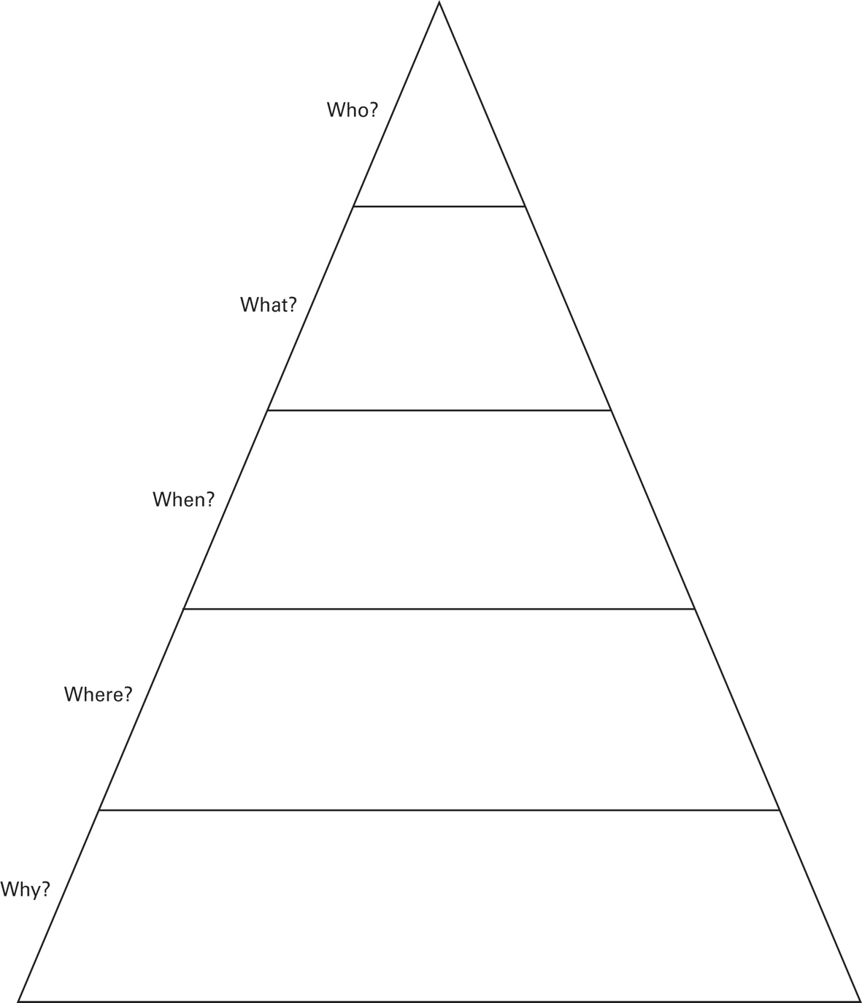
Komagata Maru Incident 5 W Pyramid

T-Chart: Are Apologies Enough?

Benefits of Apologies | Problems with Apologies

