Date Reviewed
May 2021

Course
Social Studies 2

Topic
Global Citizenship

Big Idea
Individuals have rights and responsibilities as global citizens.

Essential Questions
What can we do to make the world a better place?

Learning Standards
Content:
Students are expected to know the following:
- how people’s needs and wants are met in communities
- rights and responsibilities of individuals regionally and globally

Curricular Competencies
Students are expected to be able to do the following:
- Make value judgments about events, decisions, or actions, and suggest lessons that can be learned.

Core Competencies
Communication - I can tell a variety of ways I have changed over time and how my needs have changed.

Thinking - I can consider my rights as a Canadian citizen and what responsibilities I have to myself, my family, and others in my community.

Personal and Social - I can think of ways I can help others in my community to make our world better.

First People’s Principles of Learning
Learning involves generational roles and responsibilities.

Introduction
- Tell the students they are going to learn about changes that occur over time.
- Show some photos of babies or toddlers or have the students bring in photos of themselves when they were babies. What do they notice? (Some ideas might be: not much hair, no teeth yet, tiny, parents have to hold babies carefully, can’t walk yet, wear a diaper, drink from a bottle, etc.)
- Now, ask them to think about what they look like and can do now.
Pre-Assessment
- Ask: How have you changed over time?
- Have the class brainstorm their ideas and record on a chart. (Some ideas might include: I got more hair, teeth came in, I can feed myself, I can walk, I got glasses, I grew taller/heavier, etc.)
- Give each child a piece of paper and have them fold it in half.
- One the left side, have them draw a picture of themselves as a baby. Have them draw a thought bubble above the baby’s head and write what the baby is thinking (I need to be cuddled! or I need a bottle!)
- On the right, have them draw a picture of themselves as they are now doing something that they are now capable of doing such as riding a bike, feeding themselves or brushing their own teeth.

Interactive Learning Activities
Part 1: I Change Over Time, Communities Change Over Time
- Review: What needs did you have as a baby? (All the needs: being fed, bathed, cuddled, etc) Who made sure your needs were met? (Parent or caregiver) How have your needs changed as you grew older? (I am more capable now and can do many things for myself.)
- Distribute a copy of the handout “I Change Over Time, Communities Change Over Time” to each student.
- Record student responses on the board and have the students record a few of them on the top section of the handout.
- Ask: What is a community? (A community is a group of people who live, work and play together. People in a community interact with one another and need each other. People like to live in communities where they can feel safe to work, sleep, eat and have fun with friends and family.)
- Explain to the students: Just like you and your needs have changed over time, the needs of a community also change.
- Show the video of the book The Little House by Virginia Lee Burton (8:32)
- Discuss some of the changes in the story. How would the needs of the people living in that community change as the community grew? (More people needed more places to live, more factories to build the things they needed, less green space to make way for roads, more cars to get around because the community expanded, etc.)
- Record some answers on the board and have the children record them on the lower section of the handout.

Part 2: Different Types of Communities Have Different Needs
- Project some photos of urban and rural scenes on the screen for students to view. (These are readily available on the internet.)
- Ask: What are some differences you notice between these pictures? See if you can elicit some or all of the following vocabulary words from the students: “urban”, “rural”, “city” or “country”
- Distribute the handout “Comparing Two Types of Communities”. Help the students to label the Venn Diagram using the terms “urban” and “rural”. Add the words “city” and “country” in brackets.
- Fill in the diagram with ideas from the students:
- Urban: lots of tall buildings, many cars, shopping malls, big roads, parks, crowds of people, etc.
- Rural: fewer buildings farther apart, farms, gravel roads, lower buildings, more fields/meadows.
- Both: people live here, schools, services (police, fire, hospital, etc)
- Refer back to the photos you looked at in the beginning of the lesson if the students need more prompting.
- Show the video from BrainPOPjr Wants and Needs (3:47).
- Review the differences between wants and needs. Everyone has some things that they want and some that they need.
- What needs are different in a rural community compared to an urban community? (Eg: in a rural community people can grow their own food so they don’t need huge grocery stores. In an urban community there is public transportation so not everyone has to have a car.) What needs do all people have regardless of which type of community they live in? (People need access to schools, places to work, fresh water, food, churches, recreational facilities.)
- Ask: What happens when people have needs but are unable to meet them? (Communities have food banks, shelters and subsidized housing, etc.)

Part 3: Rights and Responsibilities
- Read the story I Have the Right to Be a Child by Alain Serres and Aurélia Fronty.
- Tell the students that all people in our country have both rights and responsibilities.
- Right: Something that every person deserves, and that cannot be taken away from them.
- Responsibility: Something that is expected of you, and that benefits everyone.
- Ask: Why must we have responsibilities to go along with rights? We can’t do whatever we want?
- Explain that we have to follow the rules or laws and respect the rights of others. Being a Canadian citizen involves maintaining and upholding rules and responsibilities so that we can live peacefully. Our core values as Canadians focus on respect. We work hard to ensure that Canadians respect themselves, each other, and the environment.
- Divide the students into pairs or small groups.
- Distribute the handout “Rights and Responsibilities”.
- Explain that they should work with their partner(s) to decide which of these phrases describe a right and which describe a responsibility and place them in separate piles.
- Set a time limit for the students to work. When the time is up, regroup as a class. Go around the room and ask each group to read aloud one of the phrases and tell you whether they thought it was a right or responsibility. Discuss, especially if there is disagreement.
- Show the CBC Kids News video Do you know your rights? NOTE: watch only from 0:00-1:44. (Some of the content past the 1:44 mark may be too mature for Grade 2)
- Have a class discussion about which rights and responsibilities are important in a classroom/school/country. What happens if someone at school does not behave responsibly?
- Project the Unicef poster The Convention on the Rights of the Child.
- Review some of the first few Articles but pay special attention to Articles 12 and 13:
- Article 12: You have the right to give your opinion, and for adults to listen and take it seriously
- Article 13: You have the right to find out things and share what you think with others, by talking, drawing, writing or in any other way unless it harms or offends other people.
- As a class, come up with a list of things children can do to make their school or community better (taking care of the environment such as cleaning up trash at a park or beach, starting a club for people with a common interest, being student ambassadors who welcome newcomers to the school, lobbying to have a school rule changed, collect food for the food bank, plant flowers or trees, etc.)

Post-Assessment
- Have the students divide themselves into groups based on their interests and brainstorm ideas as to how they could promote their cause and encourage positive change. (Write a letter, create posters, create a radio ad or film a video, create a puppet show, make a list of teacher sponsors who could help, have a bake sale to raise money to donate to the cause, etc).
- Each group can make a presentation to the class to teach their classmates about the issue they have chosen.

Extension Activities
- After reading the book I Have a Right to Be a Child, students can identify a single right that they feel is important and illustrate it in a poster. Put the posters up around the school to raise awareness.
- Create a mural of urban and/or rural communities. Have the students add people, vehicles, buildings, farms, animals, transportation, etc. that are appropriate for each type of community.
- Draft a Student’s Bill of Rights for the classroom which outlines the corresponding responsibilities of the children.
- Set aside one day during which the students practice being responsible in as many ways as they can. Have them track their actions, collect the data and celebrate the successes.

Additional References

BrainPOPEducators. 2021. “Rights and Responsibilities: Activities for Kids.”
https://educators.brainpop.com/lesson-plan/rights-and-responsibilities-activities-for-kids/?bp-jr-topic=rights-and-responsibilities

The Canadian Children’s Book Centre. 2021. “Books on Human Rights.”
https://bookcentre.ca/resources/themed-book-lists/books-on-human-rights

Historica Canada. Citizenship Canada. [n.d.] “Civics in the Classroom: The Citizenship Challenge Elementary Education Guide.”
http://education.historicacanada.ca/files/616/Civics_in_the_Classroom_-_Elementary_Education_Guide_FINAL.pdf

White, Courtney. [n.d.] “#StandForCanada: Citizenship Teaching Guide. Elementary (Grades 1 to 6).” Curio.ca. Immigration, Refugees and Citizenship Canada.
https://www.cbc.ca/curiostandforcanada/content/pdfs/elementary-guide-1.pdf

Books:

Burton, V.L. 1942. “The Little House.” Boston: Houghton Mifflin Co.

Serres, A. and Fronty, A. 2012. “I Have a Right to Be a Child.” Toronto: Groundwood Books/House of Anansi Press.

Materials and Resources

I Change Over Time

THEN | NOW

Communities Change Over Time

THEN | NOW

Comparing Two Kinds of Communities

_____________ community ______________ community

(____________) (____________)

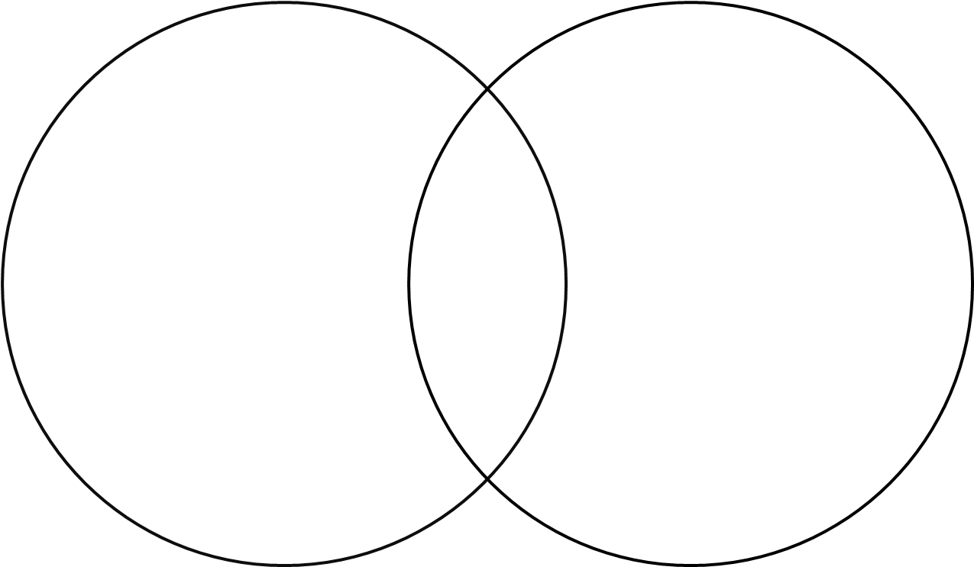

I would prefer to live in a __________________________ community

because _________________________________________________________

_________________________________________________________________

I have wants and needs.

Something I want is: | Something I need is:

Communities have needs.

People in an urban community need: | People in a rural community need:

Rights and Responsibilities

Cut out the rectangles below. Work with your partner to decide which are RIGHTS and which are RESPONSIBILITIES.

Place the ones you think are RIGHTS on one side of your desk and the RESPONSIBILITIES on the other.

To go to school | To be free and feel safe | To protect Canada’s heritage
To help people in your community | To have your own thoughts and opinions | To respect the rights and freedoms of others
To take care of the environment | To obey the law | To move and live in any province or territory in Canada
To practice your religion | To practice your culture | To have Aboriginal treaties respected
To be treated respectfully | To vote in an election when you are 18 years or older | To express your ideas, whatever they may be

