The Haudenosaunee: A unique woodland culture

Also known as the Iroquois or Six Nations, the Haudenosaunee lived in North America, in the northeastern woodland area below the Great Lakes.

Can you use your red pencil to shade this spot on your map?

Hint: This area is now part of New York State. Today, many Iroquois still live here as well as in Ontario and Quebec.

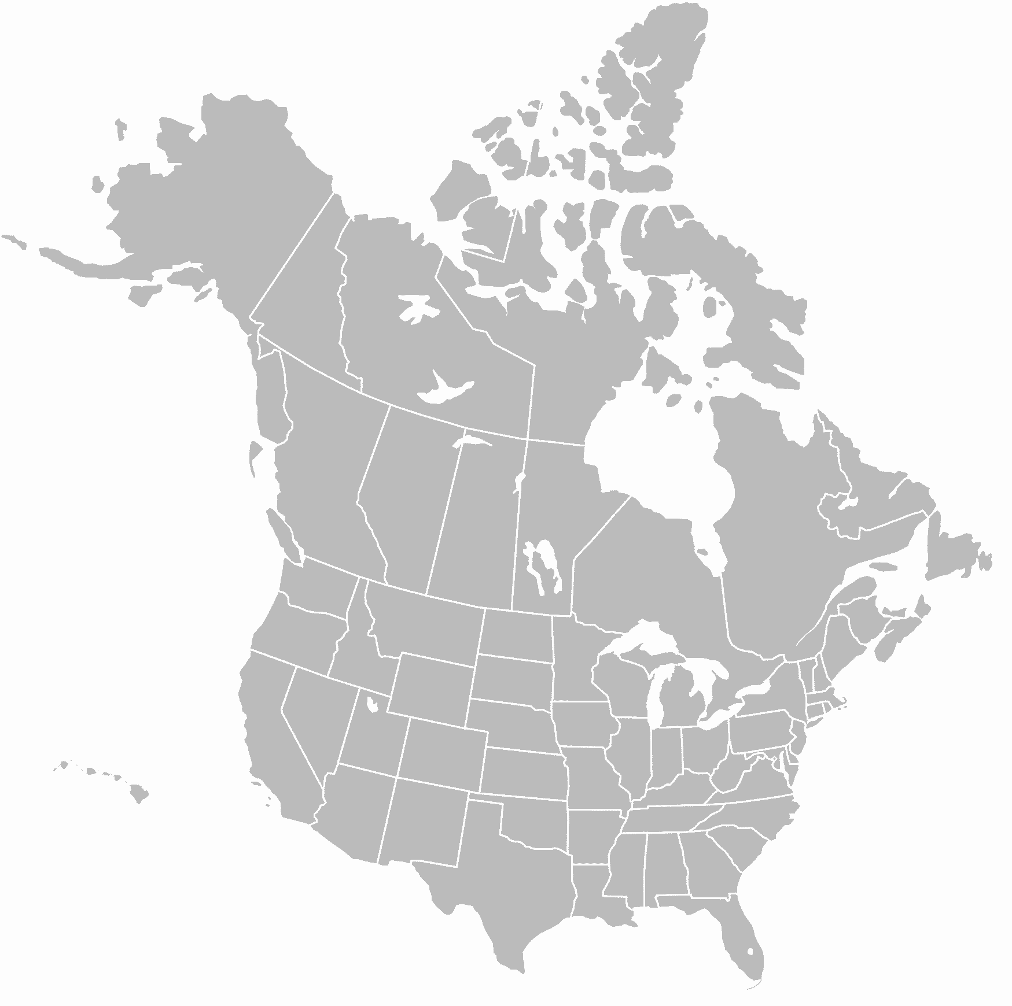

What does the name “Haudenosaunee” mean?

_________________________________________________________________

What are the names of the Six Nations that comprise the Confederacy (sometimes called the Iroquois League)?

- __________________________ 2. __________________________

3. __________________________ 4. __________________________

5. __________________________ 6. __________________________

Can you name three woodland animals that the Iroquois may have named their clans after?

________________ ___________________ ___________________

