The Three Sisters

The Iroquois were hunters, farmers and gatherers who believed in cooperation. Men and women had different roles in Iroquois society.

What was the domain of the men? __________________________________________

What was the domain of the women? ________________________________________

What plants were called “The Three Sisters”?

___________________ _________________ _________________
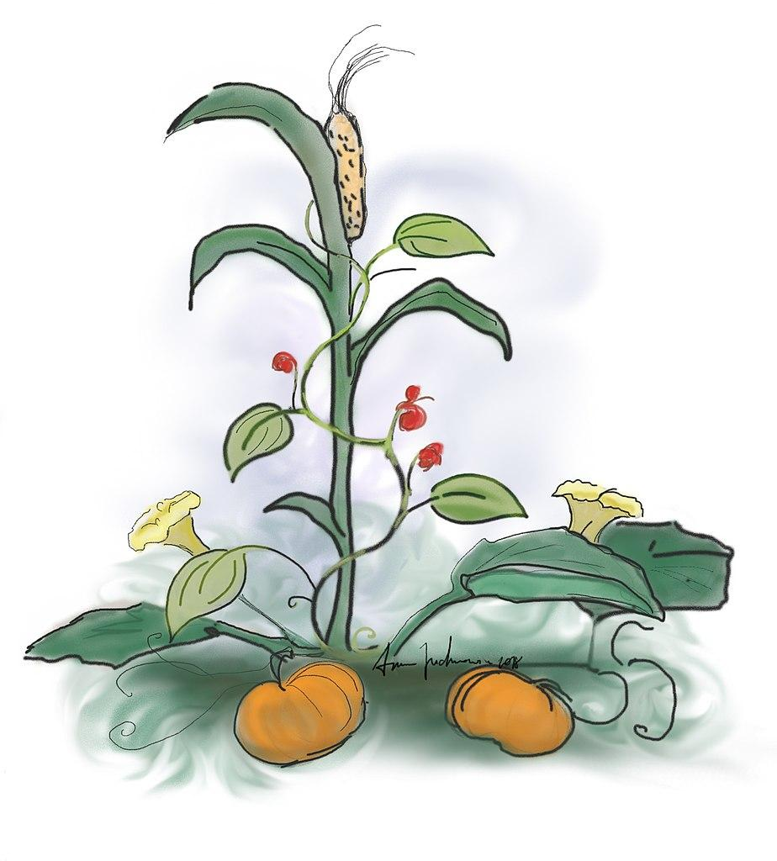

Can you describe how The Three Sisters were grown and why?

_______________________________________________________________________________

The Iroquois believed that each person was given a gift at birth. Once that gift was revealed to them, it was their responsibility to master the gift for the benefit of their community.

What do you think your gift would be? How could you use it to help your community?

________________________________________________________________________________

________________________________________________________________________________

________________________________________________________________________________

________________________________________________________________________________

________________________________________________________________________________

________________________________________________________________________________

________________________________________________________________________________

________________________________________________________________________________

________________________________________________________________________________

________________________________________________________________________________

