Date Reviewed
April 2021

Course
Social Studies 3

Topic
The Haudenosaunee People and Confederacy

Big Idea
People from diverse cultures and societies share common experiences and aspects of life.

Essential Question
How did a democratic self-government unite diverse nations in the Haudenosaunee Confederacy?

Learning Standards
Content
Students are expected to know the following:
- governance and social organization in local and global indigenous societies

Curricular Competencies
Students are expected to be able to do the following:
- Explain why people, events, or places are significant to various individuals and groups

Core Competencies
Communication - I can name the Six Nations and show their traditional territory on a map.

Thinking - I can ask questions and draw conclusions about the Confederacy and the symbols that represent Iroquois values.

Personal and Social - I can practice cooperation when I work with others and use consensus to solve a problem.

First People’s Principles of Learning
Learning is embedded in memory, history and story.

Introduction
- Tell students that they are going to learn about a group of people called the Haudenosaunee. The Haudenosaunee are sometimes called the Iroquois, Five Nations (originally) or Six Nations because they are made up of 6 different groups of First Nations peoples who joined together to form a confederacy.
- Explain that a confederacy is a group of people who cooperate to achieve common goals.
- Using a Think Pair Share strategy, ask students to think of a time that they cooperated with others in order to achieve a goal.

Pre-Assessment
- Show the BrainPOP Jr. video: Iroquois (5:04).
- Have students share with a partner: What was one interesting thing you learned from the video? What is one thing you would like to learn more about? Remind students to listen carefully to what their partner says so they can share it with the class.
- Choose a few students to report out. (For example, “My partner, Alex, thought that ________was really interesting and would like to learn more about ___________.”
- Record responses on chart paper and use check marks to show that a response has been shared by more than one student.

Interactive Learning Activities
Part 1: A Unique Woodland Culture
- Provide each student with a copy of the handout “The Haudenosaunee--A unique woodland culture”. The first side shows a map of North America. Refer back to the video and remind the students that the Iroquois lived in the northeastern woodland area south of the Great Lakes in what is present-day New York State. Many Iroquois still live in New York today as well as in southern Ontario and Quebec.
- Have the students use a red pencil crayon to shade the area on the map which shows where the Iroquois lived.
- Label the second side of the handout with the names of the Six Nations (Seneca, Cayuga, Onondaga, Oneida, Mohawk and, later, the Tuscarora). Tell students that when it was originally formed in the 1500s, there were only five nations in the Confederacy. About 200 years later, Tuscarora became the sixth nation.
- Explain that the Iroquois had a strong connection to nature and to the animals of the woodlands in which they lived. The Iroquois belonged to clans (family groups) related to a central woman called the clan mother. Women owned everything in the clan. Clans were named after some of the animals of the woodland. Ask the students to name some woodland animals that the Iroquois may have named their clans for. (turtle, bear, wolf, hawk, deer, heron, beaver, etc)

Part 2: The Three Sisters
- Provide students with the handout “The Three Sisters”.
- Using the video The People of the Longhouse, show the intro (00:00 - 00:17) and then skip forward to show 04:31 - 05:47.
- Point out that girls worked with their mothers to tend fields, gather and prepare food. They also helped their mothers use deerskin to make clothing and moccasins, wove baskets from strips of wood and learned how to plant and harvest crops. The boys learned to make bows and arrows and other tools as well as learned skills to help them become good fishermen and hunters. The men cleared fields for crops, built the longhouses and often went on long hunting and fishing trips.
- Have students use the information from the video to complete the first side of the handout.
- Point out that the Iroquois believed that each person was given a gift at birth. Once that gift was revealed to them, it was their responsibility to master the gift for the benefit of their community.
- Ask: What do you think your gift would be? How could you use it to help your community? Have students record their ideas on the second side of the handout.

Part 3: People of the Longhouse
- Tell students that they will be learning about Iroquois homes. Remind them that some First Nations groups were nomadic (they moved around in order to find food/depending on the season). Connection: what other First Nations groups have we learned about that are nomadic? What types of homes did they live in? (teepees, etc that were not permanent and could be easily moved)
- Ask the students if they know the word that means the opposite of “nomadic” (sedentary). The Iroquois are considered sedentary. This means that they stayed in one place.
- Ask: How could we guess that the Iroquois stayed in one place? (Longhouses are huge and probably took a long time to build so they were not easy or practical to move. Also, we know that the Iroquois were mainly farmers so they would stay near their crops rather than moving around to find food. In fact, they would only move on every 10-20 years.)
- Show the video Life in a Longhouse (2:50).
- Provide each student with a copy of the handout “The Haudenosaunee: People of the Longhouse”,
- Have the students work with a partner to complete the vocabulary activity on the handout.
- Show the video The Building of the Iroquois Longhouse (11:00).
- Pause to draw students’ attention to some of the design features and to discuss the process as they watch.
- Ask: What do you think it would be like to live in one huge house with 100 or 200 other people? What would be the benefits of living with others in a communal home such as a longhouse? Can you think of any drawbacks? Hint: What Iroquois value did we learn about that would make living together easier? (Cooperation)

Part 4: The Six Nations Confederacy
- Ask: What is a symbol? Show some other easily recognizable symbols and ask the students to identify them (flags, poppy, stop signs, etc). Ask: What are some symbols of Canada? (Maple Leaf, beaver, hockey stick…)
- Provide each student with a copy of the handout “The Haudenosaunee: The Six Nations Confederacy”.
- Have students consider what symbol represents them and complete the first page of the handout by drawing and writing about a symbol that represents them.
- Have some or all students share with the class what they chose as a personal symbol.
- Review the names of the Six Nations. Discuss the symbols of the Six Nations on the handout.
- Tell this version of the story of “The Peacemaker”: Before the Europeans came, the Iroquois nations were often at war, fighting over hunting lands. One day a man came to the Iroquois in the 1400s or 1500s and told them that their nations needed to work together to prevent wars and that by uniting together, they would become stronger and keep their people safe. Women were the first people to accept this idea and they became the leaders of their communities. The story says that the people uprooted the tallest pine tree and threw all their weapons into the hole where an underground stream carried them away. They then replanted the “Great Tree of Peace” and four white roots spread out in all four directions. The chiefs of each tribe formed a council and sat beneath the tree to create the laws that would govern the nations.
- Show the video The Peacemaker's Journey and The Great Law of Peace (4:12).
- On the second page of the handout, look at the image of the Tree of Peace and discuss what the students think the different parts symbolize. (Eagle - can see far and warn the people of the Confederacy of any danger. Tree branches - represent the protection of the nations under the Great Law of Peace. Roots - represent peace and strength. They spread out in the four directions: north, south, east and west. The roots lead anyone or any nation willing to follow the Great Law of Peace to the shelter under the tree. The weapon - shows that the Iroquois will not fight against each other. They have thrown the weapons of war into the depths of the earth.)
- The Great Law of Peace established an alliance among the nations. An alliance is an agreement among nations to support one another.
- Look at the map of the original Five Nations on the handout “The Haudenosaunee: A unique woodland culture”.
- Remind the students that the Tuscarora joined the Confederacy in the early 1700s. Until then there were only five nations.
- Tell the students that each nation in the confederacy had a role. For example, the Mohawk were the “Keepers of the Eastern Door”. They defended the confederacy from the east. Ask: based on the map, who would have defended the confederacy at the “Western Door”? (Seneca). One nation was charged with keeping the principles of the confederacy alive - this held the center of the confederacy firm. They were called the “Keepers of the Council Fire”. Which group was this? (Onondaga) Students record answers on their handoutt.
- The two nations that defended the “Doors” to the confederacy were called the “older brothers”. Which were these? (Mohawk and Seneca)
- The nations in the center were called the “younger brothers”. Which were they? Students record answers on their handout.
- Tell the students: Each nation sent chiefs to League council meetings. The council met at least once a year. Anything that concerned all the nations was discussed at these meetings. The Mohawk and Seneca sat on the east side of the fire. The Oneida and Cayuga sat across from them on the west side. To the north were the Onondaga who presided over the meetings. All decisions had to be made unanimously - that is, everyone had to agree. This is called a consensus. When a decision had to be made there was a process. First each nation would discuss amongst themselves and come to a decision. Then, each nation would discuss their decision with the other group on their side of the fire. When the Mohawk and Seneca were in agreement, they would send their decision across the fire to the Cayuga and Oneida. When all four agreed, the decision was told to the Onondaga. If they agreed then the League could “speak with one voice”.

Part 5: Problem-Solving by Consensus
- Divide students into 5 groups named for the five nations. Have them arrange themselves as the nations did and give them a simple problem (eg. one group wants to use the field to play soccer at recess and another group wants to play kickball on the same field. How can this problem be solved?)
- Guide the students to solve the problem using consensus like the council would.
- Ask: How did this way of problem-solving work for you? Did every group get a fair and equal opportunity to share their own ideas? When a decision is made by consensus, everyone “wins” because everyone has had a chance to make their ideas part of the solution.
- Have the students complete the handout “Problem Solving by Consensus”.
- Read “The Legend of the Three Sisters”. Ask: How did the Three Sisters model the way Iroquois society functioned?

Post-Assessment
- Ask: Why are the Haudenosaunee referred to as a confederacy? How did living in the eastern woodlands affect the type of lifestyle the Iroquois lived? What do you think present day culture could learn from the ways of the Haudenosaunee?
- Using a Gallery Walk strategy, put 3 sheets of chart paper on the wall - label the first “Woodland Culture”, the second “Longhouses” and the third, “Confederacy”. Give the students sticky notes or markers and have them add new learning to each chart paper.

Extension Activities
- Using found materials, students can create a model of an Iroqois longhouse
- Create a booklet that teaches younger students some interesting facts aboutroquois culture. Write and illustrate with pictures.
- Draw a cartoon that tells the story of the Peacemaker.
- Learn about Oren Lyons, Iroquois speaker and Faithkeeper. Research his life and write a short paragraph about his role as an Iroquois leader.
- Provide the students with a sheet divided into four boxes. Label each sheet with one topic such as “Food”, “Weapons and tools”, “Shelters”, etc. Use each sheet to compare what they have learned about the Iroquois with new learning about three other indigenous groups from around the world.
- Create a timeline of important events in Iroquois history

Additional References

Baker, J. 2021. "Origins of the Haudenosaunee (Iroquois) Confederacy." World History Encyclopedia. https://www.worldhistory.org/article/1656/origins-of-the-haudenosaunee-iroquois-confederacy/

“Haudenosaunee Guide for Educators.” [n.d.] National Museum of the American Indian.
https://americanindian.si.edu/sites/1/files/pdf/education/HaudenosauneeGuide.pdf

“Iriquois Homes.” 2021. Mr. Nussbaum. Learning and Fun. https://mrnussbaum.com/iroquois-homes

“Native Americans: Iroquois Tribe.” 2021. Ducksters. https://www.ducksters.com/history/native_american_iroquois.php

Ramsden, P., 2015. “Haudenosaunee (Iroquois).” The Canadian Encyclopedia. https://www.thecanadianencyclopedia.ca/en/article/iroquois

Ramsden, P.G., 2006; 2015. "Haudenosaunee (Iroquois)". The Canadian Encyclopedia. Historica Canada. https://www.thecanadianencyclopedia.ca/en/article/iroquois

“Spotlight on Native Americans. Iroquois (Haudenosaunee). Lesson Plan” [n.d.]
http://www.onlinereferencecentre.ca/uploads/1/4/9/8/14986284/iroquois_lesson_plan.pdf

“The Great Tree of Peace. Basic Level Teachings. Unit 3. Teacher’s Manual.” 2010. Ontario Native Literacy Coalition. https://onlc.ca/wp-content/uploads/2017/04/Unit-3-The-Great-Tree-of-Peace1.pdf

“The Iroquois Confederacy.” 2021. Cool Kid Facts. https://www.coolkidfacts.com/iroquois-confederacy/

The Legend of the Three Sisters. [n.d.] Oneida.
https://www.oneidaindiannation.com/the-legend-of-the-three-sisters/

“What was the Iroquois Confederacy?” [n.d.]
https://www.nelson.com/albertasocialstudies/productinfo/gr6_9/documents/abss6ch4draft.pdf

Books

Englar, M. “The Iroquois The Six Nations Confederacy.” 2016. Revised Edition. Capstone Press: North Mankato, MN.

Levine, E. and S. Hehenberger. 1998. “If You Lived with the Iroquois.” New York: Scholastic.

Johnson, M. G. 2013. “Iroquois People of the Longhouse.” [n.l.]: Firefly Books Ltd.

Materials and Resources

The Haudenosaunee: A unique woodland culture

Also known as the Iroquois or Six Nations, the Haudenosaunee lived in North America, in the northeastern woodland area below the Great Lakes.

Can you use your red pencil to shade this spot on your map?

Hint: This area is now part of New York State. Today, many Iroquois still live here as well as in Ontario and Quebec.

What does the name “Haudenosaunee” mean?

_________________________________________________________________

What are the names of the Six Nations that comprise the Confederacy (sometimes called the Iroquois League)?

- __________________________ 2. __________________________

3. __________________________ 4. __________________________

5. __________________________ 6. __________________________

Can you name three woodland animals that the Iroquois may have named their clans after?

________________ ___________________ ___________________

The Three Sisters

The Iroquois were hunters, farmers and gatherers who believed in cooperation. Men and women had different roles in Iroquois society.

What was the domain of the men? __________________________________________

What was the domain of the women? ________________________________________

What plants were called “The Three Sisters”?

___________________ _________________ _________________
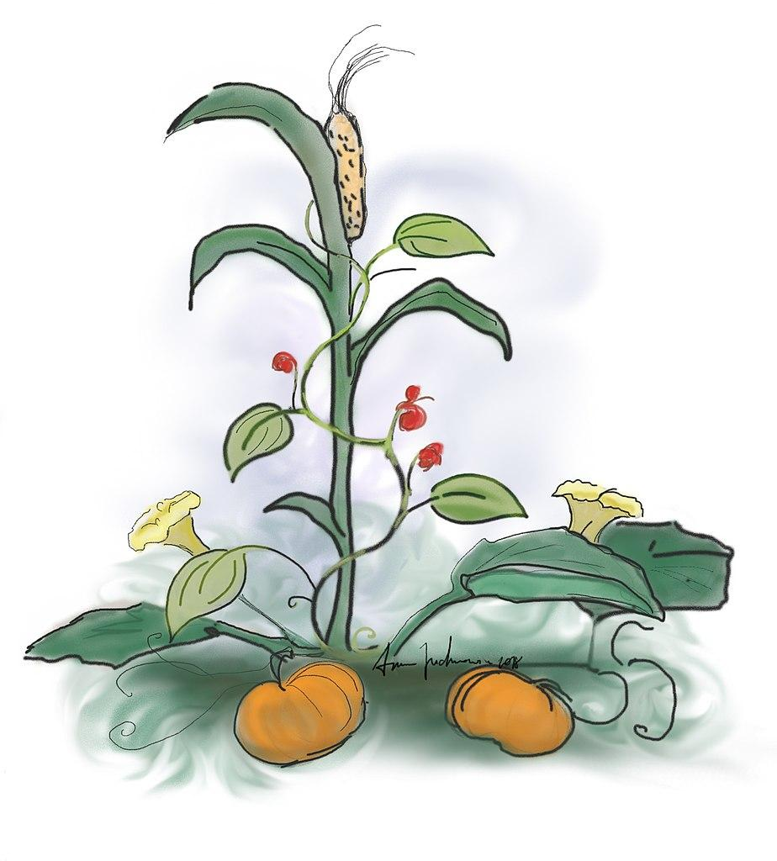

Can you describe how The Three Sisters were grown and why?

_______________________________________________________________________________

The Iroquois believed that each person was given a gift at birth. Once that gift was revealed to them, it was their responsibility to master the gift for the benefit of their community.

What do you think your gift would be? How could you use it to help your community?

________________________________________________________________________________

________________________________________________________________________________

________________________________________________________________________________

________________________________________________________________________________

________________________________________________________________________________

________________________________________________________________________________

________________________________________________________________________________

________________________________________________________________________________

________________________________________________________________________________

________________________________________________________________________________

The Haudenosaunee: People of the Longhouse

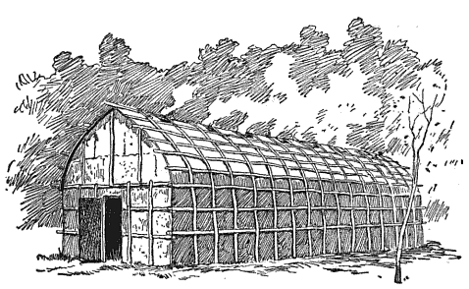

Use the following vocabulary words to fill in the blanks in the passage. Cross each word off as you use it.

smokeholes bark doors protection palisade crops curved longhouses football field sedentary fire windows village families

The Iroquois were farmers and so they were ________________. This means they lived in one place and did not move around a lot. Instead, they built their homes near streams so they could be near their fields of ____________. Several of their homes, called ____________________, were built together in one ________________. The village would be surrounded by a type of fence called a ______________ that was about 15 to 20 feet high. This offered _________________ from attacks.

A longhouse was built with upright poles and logs and had a ______________ roof. It was covered with _________. There were two ____________ but no ___________________! The roof had ________________ so the people could always keep their fires going to cook and stay warm. Many _____________ lived together in one longhouse. Each family had their own section. The two families across the aisle from each other would share one ____________. If they needed to make room for more families, they could add to the longhouse. Depending on how many families lived there, a longhouse could be 150 feet in length. That’s as long as half of a _____________________!

The Haudenosaunee: The Six Nations Confederacy

In the box below, draw a symbol that represents you:

Tell what the symbol is and why you chose it:

_____________________________________________________________________

_____________________________________________________________________

_____________________________________________________________________

_____________________________________________________________________

The symbols of the six nations

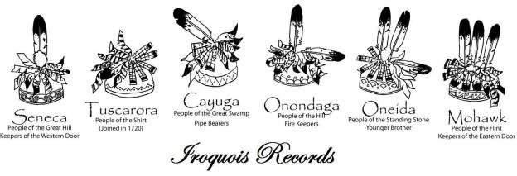

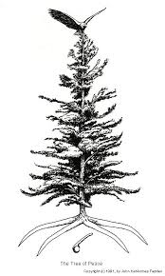
The Symbols of the Tree of Peace:

The eagle _____________________________

____________________________________

The branches __________________________

____________________________________

The roots _____________________________

____________________________________

The weapon ___________________________

____________________________________

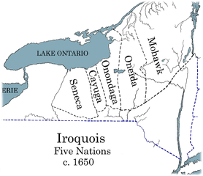

The Keepers of the Eastern Door were the
_____________________________

The Keepers of the Western Door were the
_____________________________

The Keepers of the Council Fire were the
____________________________

The “older brothers” were ______________________
and _______________________

The “younger brothers” were ______________,
_______________ and _______________

Problem Solving by Consensus

All the decisions of the Confederacy were made by consensus which means that everyone had to agree.

Do you think this was a fair way to decide important matters? _________

Why or why not?

________________________________________________________________________________

________________________________________________________________________________

________________________________________________________________________________

________________________________________________________________________________

________________________________________________________________________________

________________________________________________________________________________

________________________________________________________________________________

________________________________________________________________________________

________________________________________________________________________________

The Legend of the Three Sisters (from the Oneida Indian Nation)
Very long ago, there were three sisters who lived in a field. The youngest was so small she could not yet walk; she crawled along the ground, dressed in green. The middle sister wore a bright yellow dress and darted back and forth across the field. The eldest sister stood tall and straight, and her body bent with the wind. She had long yellow hair and wore a green shawl. The three sisters loved one another very much and could not imagine living without the others.
One day a little Indian boy came to the field. He was very handsome and knew the ways of the land. He could talk with the birds and the animals and was straight and fearless. The three sisters were very interested in this boy as they watched him use his stone knife to carve a bowl or hunt with his bow and arrow.
Late in the summer of the boy’s first visit to the field, the youngest of the three sisters disappeared. She was the one who could only creep along the ground; she could not even stand unless there was a stick she could cling to. But she was gone, and the other two sisters mourned her until the fall.
The Indian boy returned to the field to gather reeds that grew at the edge of a small stream. He used the reeds to make arrow shafts. The two remaining sisters again watched him, fascinated. That night, the second sister disappeared, the one who always wandered hither and yon.
Now there was only one sister left, the tall and straight sister. She did not bow her head in sorrow, though she mourned deeply and thought she could not live in the field alone without her sisters. As the days grew shorter and colder, her green shawl began to lose its color and her yellow hair became dry and tangled. Night and day she sighed for her sisters, but her voice was low like the wind, and no one heard her.
One day in the harvest season, the little Indian boy heard the third sister crying, and he felt sorry for her. He took her in his arms and carried her to his home, and there a delightful surprise awaited her: Her sisters were there in the lodge, safe and very glad to be reunited. They explained that they had been curious about the little Indian boy and had followed him home, and they had decided to stay because winter was coming and his home was warm and comfortable.
The sisters also were making themselves useful to the boy and his family. The youngest, now all grown up, kept the dinner pot full, while the second sister, still in her yellow dress, dried herself on the shelf so she could fill the dinner pot later in the winter. The eldest sister was so pleased to be with her sisters again and so impressed with the help they gave the boy that she too began drying herself so the family would have meal to use as the winter went on.
And from that day to this, the three sisters were never separated again.

