Date Reviewed
March 2021

Course
Social Studies 4

Topic
Fur Trade

Big Idea
The pursuit of valuable natural resources has played a key role in changing the land, people, and communities of Canada.

Essential Question
How did the fur trade lead to the development of Canada?

Learning Standards
Content:
Students are expected to know the following:
- the fur trade in pre-Confederation Canada and British Columbia

Curricular Competencies
Students are expected to be able to do the following:
- construct narratives that capture the attitudes, values, and worldviews commonly held by people at different times or places (perspective)

Core Competencies
Communication - I can summarize key ideas about how fur trading started and developed in Canada.

Thinking - I can analyze how the fur trade created relationships between Indigenous peoples and Europeans.

Personal and Social - I can consider what life would have been like for various participants in the fur trade.

First People’s Principles of Learning
- Learning is embedded in memory, history, and story.

Introduction
- Project or handout copies of the images “Animals of Canada”.
- Ask “Which animal is the symbol of Canada?” Have students provide reasons for their predictions.
- Explain that while all these animals are found in Canada, the beaver is Canada’s official symbol because of its importance to the fur trade. Point out that there were about six million beavers in Canada before the start of the fur trade. During the fur trade, 100,000 beaver pelts were being shipped to Europe each year. As a result, the beaver was in danger of becoming extinct.
- Show the short video Beaver Pelt Trade (3:47).
- Ask: Why was beaver fur so popular and valuable?

Pre-Assessment
Think Pair Share: How did the fur trade create Canada?

Interactive Learning Activities

Part 1: Trade Goods & Cultural Exchange
- Have students turn to a partner and tell about a time they traded something. Ask why they wanted to trade and if they made a fair trade.
- Provide students with the handout “Reasons for Trade”. Have students work with a partner to complete the reading and make notes in the chart.
- Explain that Europeans wanted furs. They had the power of money and guns. First Nations were the hunters and trappers. They had the power of controlling the fur supplies. They also had knowledge of the land. Fur traders depended on First Nations for their business and survival. First Nations and Europeans were equal partners in the fur trade.
- Have students write a journal from the perspective of an indigenous person hunting beaver for the fur trade. How has contact with Europeans changed your life? What do you enjoy about your life? What challenges do you face?

Part 2: The French Fur Trade
- Explain that the French were the first European settlers in what would become Canada. They called this land New France.
- Provide students with the handout “The French Fur Trade”. Have students work with a partner to complete the reading and answer the questions.
- Show the National Film Board video The Voyageurs (19:52).
- Have students write a journal from the perspective of a voyageur. What do you enjoy about your life? What challenges do you face? How has contact with Indigenous people changed your life?

Part 3: The British Fur Trade
- Provide students with the handout “The British Fur Trade”. Have students work with a with a partner to complete the reading and the Venn Diagram compaing the Hudson’s Bay Company with the North West Company.
- Show the short National Film Board video Trading Post (0:59). *Note that this film was made in 1978 and refers to Indigenous peoples as Indians.
- Have students write a journal from the perspective of an HBC employee at a fur trading fort. What do you enjoy about your life? What challenges do you face? Is your trade with the Indigenous peoples fair?

Post-Assessment
Placemat Activity: How did the fur trade create Canada?

Extension Activities
Play the Fur Trader Game.

Additional References

Brown, Jennifer, S.J. “Beaver Pelts.” The Canadian Encyclopedia, 19 Aug. 2015,
https://www.thecanadianencyclopedia.ca/en/article/beaver-pelts

Canadian Geographic. “Fur Trade.” Indigenous Peoples Atlas of Canada. [n.d.],
https://indigenouspeoplesatlasofcanada.ca/article/fur-trade/

Foster, John E, et al. “Fur Trade in Canada.” The Canadian Encyclopedia, 1 Nov. 2019,
https://www.thecanadianencyclopedia.ca/en/article/fur-trade

“Fur Trade Educational Package.” Canada’s History. [n.d.],
https://www.canadashistory.ca/education/kayak-in-the-classroom/fur-trade-history/fur-trade-educational-package

Fur Trade Questions. [n.d.]
http://tepringle.weebly.com/uploads/8/8/2/9/8829030/fur_trade_questions.pdf

Wargin, Kathy-Jo. “The Voyageur’s Paddle.” Ann Arbor, MI: Sleeping Bear Press, 2007.

Canadian Encyclopedia: Fur Trade in Canada
https://www.thecanadianencyclopedia.ca/en/article/fur-trade-in-canada-plain-language-summary

Materials and Resources

Animals of Canada

All of these animals live in Canada.
Which one do you think is the official symbol of Canada?

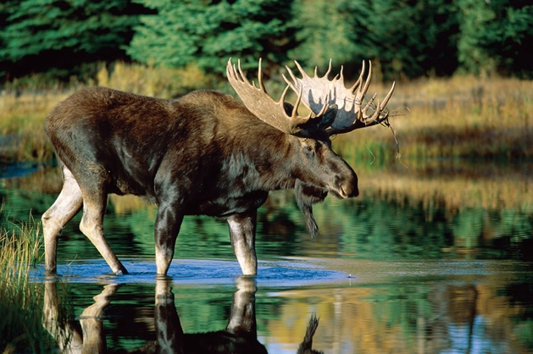  moose | 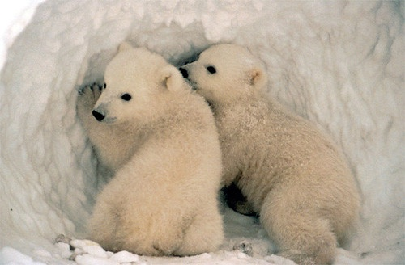  polar bear
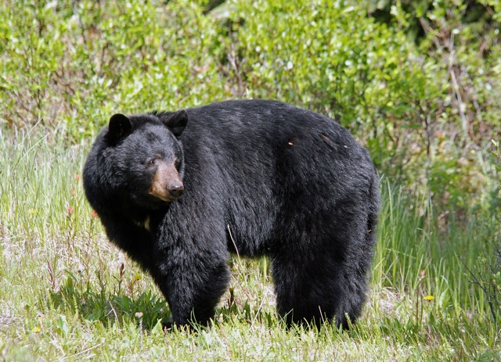  black bear | 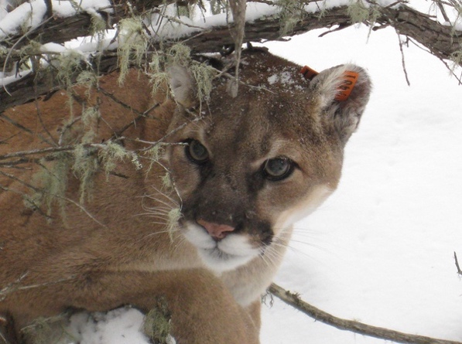  mountain lion
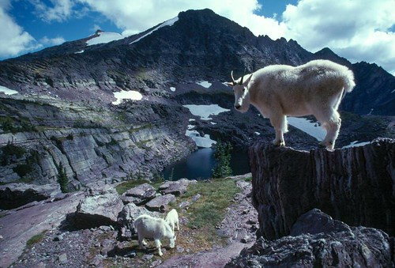  mountain goat | 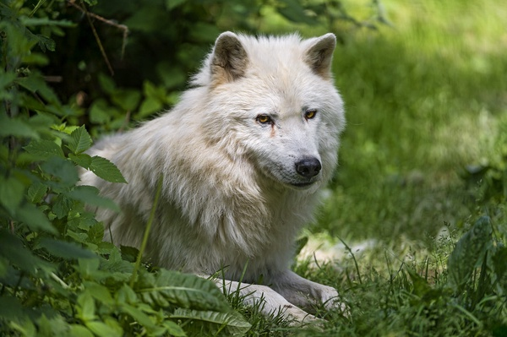  Arctic wolf
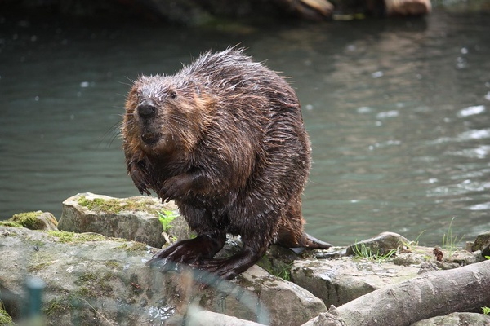  beaver | raccoon
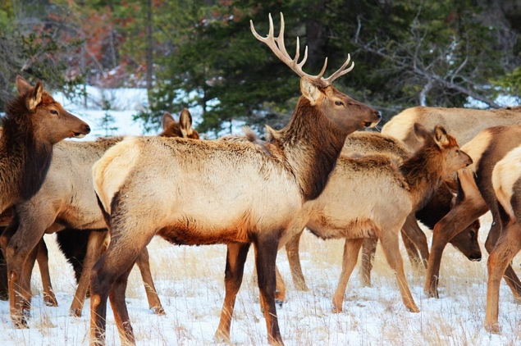  elk | 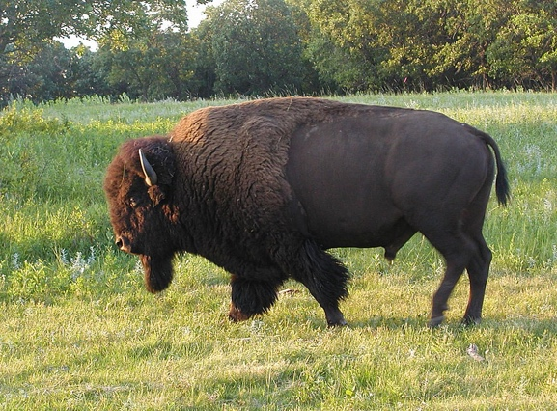  bison

Reasons for Trading

Indigenous peoples adopted items of European manufacture because the technology often was convenient. For example, flintlock muskets, iron axes and knives and brass kettles were considered more efficient than the bows and arrows, stone tools and birchbark baskets they replaced.

Trade goods, however, were not limited to practical objects. A pipe of tobacco may not have made a trapper more efficient, but it did make him more serene. Similarly, Indigenous women could have tied back their hair with strips of skin, as had their ancestors for countless generations, but they found a brightly coloured ribbon offered by the Europeans attractive.

For Europeans, their purpose for trading was to gain valuable furs. During periods of contact, some Europeans, like the voyageurs, adopted Indigenous technologies and clothing as well. This includes, for example, moccasins, types of buckskin clothing and snowshoes.

(excerpt from Trade Goods of the Fur Trade, Canadian Encyclopedia)

 | First Peoples | Europeans
Why did they want to trade?

What goods they get?

What new knowledge did they get?

The French Fur Trade

The most important players in the early fur trade were Indigenous peoples and the French. The French gave European goods to Indigenous people in exchange for beaver pelts. The fur trade was the most important industry in New France. With the money they made from furs, the French sent settlers to Canada. These were mainly traders and religious missionaries. Missionaries worked to convert Indigenous people to Christianity.

Coureurs des bois (“runners of the woods”) and voyageurs did much to expand the fur trade. They travelled inland and traded with Indigenous peoples. Coureurs des bois were unlicensed traders from New France. A voyageur was like a coureur des bois. The main difference between them is that a voyageur had a license from the government to trade. Voyageurs appeared in the 1680s when the government introduced these licenses.

Traders and explorers often relied on the knowledge of Indigenous guides. Many of the coureurs des bois and voyageurs married Indigenous women. They did so mainly to establish good trading relations. Their descendants are called Métis. The Métis are a recognized Indigenous people in Canada.

(excerpt from Fur Trade in Canada, Canadian Encyclopedia)

How did the French try to change the Indigenous peoples?

How did the Indigenous peoples influence the French traders and explorers?

Who are the Métis?

The British Fur Trade

The British wanted to make money from the fur trade, too. They created the Hudson’s Bay Company (HBC) in 1670. The HBC received control of Rupert’s Land. This was a vast area in the heart of the continent. Like the French, the HBC and other British fur traders gave goods to Indigenous people in exchange for beaver pelts.

Britain became the master of the fur trade in North America after it took control of New France in the 1760s. The most important fur trading companies were the Hudson’s Bay Company and the North West Company (NWC). The NWC was founded in 1779. The HBC and the NWC were fierce rivals. Both companies expanded westward. Explorers Alexander Mackenzie, Simon Fraser and David Thompson (all employees of the NWC) began the fur trade in British Columbia. In 1821, the North West Company merged with the stronger Hudson’s Bay Company.

George Simpson, the governor of the HBC’s trading territories from 1826 to 1860, made the company very rich. He founded new trading posts in the West, cut costs and defeated his rivals. By the mid-1800s, however, the HBC began to decline. Europeans were less interested in fur than they had been before. The federal government of Canada bought Rupert’s Land from the HBC in 1870. In the following decades, tens of thousands of settlers began to move to Western Canada.

(excerpt from Fur Trade in Canada, Canadian Encyclopedia)

The Hudson’s Bay Company and the North West Company were rivals. How were they similar? How were they different?

HBC NWC

