Date Reviewed
January 2021

Course
Law Studies 12

Topic
Rights of the Accused

Big Idea
Understanding legal rights and responsibilities allows citizens to participate more fully in society.

Essential Question
How are the rights of the accused upheld during trial procedures in accordance with the Canadian Charter of Rights and Freedoms?

Learning Standards
Content
Students are expected to know the following:
- Structures and powers of the federal and provincial courts and administrative tribunals
  - Rights of the accused

Curricular Competencies
Students are expected to be able to do the following:
- Make reasoned ethical judgments about controversial decisions, legislation, or policy

Core Competencies
Communication
I can identify the legal rights in the Canadian Charter of Rights and Freedoms and discuss their importance.

Thinking
I can present examples of how Canadian Charter of Rights and Freedoms protects the rights of accused persons.

Personal and Social
I can reflect on my own misconceptions and biases regarding the rights and treatment of accused persons in court.

First People’s Principles of Learning
Learning requires patience and time.

Introduction
- Write the following statement on the board: “It is better that ten guilty persons escape than that one innocent suffer.”
- Using the Barometer Strategy, label one side of the room “strongly agree” and the other “strongly disagree”. Have students stand anywhere between the two extremes, depending on how much they do or do not agree with the statement. Ask students to explain why they have chosen to stand where they are standing.
- Guide students to consider the consequences of a criminal record and incarceration. Introduce the protections against wrongful conviction: proof beyond a reasonable doubt, onus on the crown to prove guilt, innocent until proven guilty, procedural protection, disclosure requirements, and the Charter.

Pre-Assessment
- Hand out the “Rights of the Accused: Misconception Check” worksheet. Students will read statements regarding legal rights and circle true or false under each statement. This is an individual and a silent activity.
- After students are finished, discuss each statement one by one. Encourage students to think deeply and identify why they believe a certain statement to be true or false before revealing the correct answers using the “Answer Key with Elaborations”.

Interactive Learning Activities
- Provide students with the handout “Courtroom Participants”. Have students discuss the roles of each individual.
- Introduce the essential question: “How are the rights of the accused upheld during trial procedures in accordance with the Canadian Charter of Rights and Freedoms?”
- Explain that students will be making a concept map about the rights of the accused. Discuss the definition of a concept map before beginning. A concept map, or a mind map, is a way to visually represent concepts by breaking them down into specific topics and examples using circles, squares, connecting lines, arrows, etc. It is a way to structure knowledge by providing a method to understand connections and examples.
- Provide students with the assignment “Rights of the Accused: Concept Map”. Students can work individually or in small groups. Their concept map will include the topic at the center, a legal right from the Charter, and an example (original student idea) of how this would be upheld during trial procedures.
- Students start by identifying the main components on the concept map (different legal rights in the Charter of Rights and Freedoms). Then, students will use resources provided to come up with their own ideas of examples for each legal right.
- As students work to identify examples, they should discuss relationships between different components.
- After students are finished, allow time to compare, contrast, and discuss the different concept maps. Focus will be on the examples given for the different legal rights.
- Remind students of the essential question, “How are the rights of the accused upheld during trial procedures in accordance with the Canadian Charter of Rights and Freedoms?”. They will write a short paragraph responding in their own words.

Post-Assessment
- Handout the assignment “Legal Rights: Expository Essay”.
- Students will choose one of the legal rights from the Charter of Rights and Freedoms to investigate. Learning activities have focused on Section 10-14 which focus mainly on the rights of the accused during trial, but students may choose any of the legal rights from Section 7-14.
- Students will write an expository essay on one of these legal rights. The essay will define the right and evaluate how it has been applied in Canada. Students will expand on that idea by discussing particular legal cases or controversies related to the legal right.
- Assess essays using “Legal Rights: Expository Essay Rubric”.

Extension Activities
- Have students collaborate with a classmate to create a pamphlet that could be used for legal aid to inform the accused of their rights.
- Have students rank the legal rights in the Charter from most to least important (in their opinion). Use these rankings as a basis for a class discussion.

Additional References
British Columbia. 2019. “Your Rights - Information for Accused.” Ministry of Public Safety and Solicitor General. https://www2.gov.bc.ca/gov/content/justice/criminal-justice/bcs-criminal-justice-system/if-you-are-accused-of-a-crime/your-rights
Canada. [n.d.] “Canada’s Criminal Justice System: Getting Fair Outcomes for Victims in Canada’s Criminal Justice System.” Office of the Federal Ombudsman for Victims of Crime. https://www.victimsfirst.gc.ca/res/pub/gfo-ore/CCJS.html
Canada. 2021. “Section 11 – General: legal rights apply to those "charged with an offence".” Department of Justice. https://www.justice.gc.ca/eng/csj-sjc/rfc-dlc/ccrf-ccdl/check/art11.html
Canadian Resource Centre for Victims of Crime. 2021. “Rights.” Ottawa, ON. https://crcvc.ca/for-victims/rights/
Éducaloi. 2021. “Rights of a Person Accused of a Crime.” https://educaloi.qc.ca/en/capsules/rights-of-a-person-accused-of-a-crime/
“Legal Rights.” 2006. Canadian Charter of Rights and Freedoms. Fundamental Freedoms Project. http://charterofrights.ca/en/16_00_01
Murphy, Terry, et. al. All About Law: Exploring the Canadian Legal System, 6th ed., Nelson Canada, 2009.
Ontario Court of Justice. 2012. “Guide for Accused Persons in Criminal Trials.” Ontario Court of Justice. https://www.ontariocourts.ca/ocj/self-represented-parties/guide-for-accused-in-criminal-cases/guide/
People’s Law School. 2018. “Charter Rights: Overview.” Dial-A-Law. British Columbia. https://dialalaw.peopleslawschool.ca/charter-rights-overview
Purdue University. 2020. “Expository Essays.” Purdue Writing Lab. https://owl.purdue.edu/owl/general_writing/academic_writing/essay_writing/expository_essays.html#:~:text=The%20expository%20essay%20is%20a,a%20clear%20and%20concise%20manner
Roach, K. and M.L. Friedland. [n.d.] “The Right to a Fair Trial in Canada.” http://hrlibrary.umn.edu/fairtrial/wrft-kr.htm
Rosenberg, Marc, Hon. 2009. “Twenty-Five Years Later: The Impact of the Canadian Charter of Rights and Freedoms on the Criminal Law,” Ontario. Court of Appeal. https://www.ontariocourts.ca/coa/en/ps/publications/twenty-five_years_later.htm

Materials and Resources:

Rights of the Accused: Misconception Check

Instructions: Below is a series of statements that refer to the legal rights of a person who is accused (i.e. has been arrested and then charged) of a crime. Decide whether the statement is true or false and circle the corresponding word.

1. An accused person has the right against any search of their person.

True False

2. An accused person has the right to an interpreter in a court proceeding.

True False

3. An accused person does not have to be told what offence they are charged with.

True False

4. An accused person does not have to be allowed bail and is usually kept in custody until the trial.

True False

5. An accused person has the right to get a lawyer immediately after they are arrested.

True False

6. An accused person, when there is a great deal of evidence against them, may be found guilty before a legal trial takes place.

True False

7. An accused person has the right to a trial within a reasonable amount of time.

True False

8. An accused person has the right to trial by jury if an offence can be punished with imprisonment for five years or more.

True False

9 . A person has the right not to be arrested for no reason.

True False

10 . An accused person has the right to not undergo cruel or extreme punishment.

True False

Reference:

“Your Rights - Information for Accused.” Province of British Columbia, Ministry of Public Safety and Solicitor General, 14 Jan. 2019, www2.gov.bc.ca/gov/content/justice/criminal-justice/bcs-criminal-justice-system/if-you-are-accused-of-a-crime/your-rights.

Answer Key with Elaborations
Rights of the Accused: Misconception Check

Instructions: Below is a series of statements that refer to the legal rights of a person who is accused (i.e. has been arrested and then charged) of a crime. Decide whether the statement is true or false and circle the corresponding word.

1. An accused person has the right against any search of their person.

(False. Section 8 - The right to be secure against unreasonable search and seizure. There are many situations in which it would be reasonable to search a person - i.e. if they are arrested, searching them for weapons)

2. An accused person has the right to an interpreter in a court proceeding.

(True. Section 14 of the Charter.)

3. An accused person does not have to be told what offence they are charged with.

(False. Section 11 - The right to be informed without unreasonable delay of the specific offence you are charged with.)

4. An accused person does not have to be allowed bail and is usually kept in custody until the trial.

(False. Section 11 - The right to reasonable bail unless there is just cause (a good reason) to deny it).

5. An accused person has the right to get a lawyer immediately after they are arrested.

(True. Section 10 - The right to know why you’re arrested, to speak to a lawyer immediately and to be told that you have that right.)

6. An accused person, when there is a great deal of evidence against them, may be found guilty before a legal trial takes place.

(False - Section 11 - Rights if you’re charged with an offence, including - The right to be presumed innocent until proven guilty). The accused may, however, plead guilty at any point up until a judge or jury finds them guilty or not guilty.

7. An accused person has the right to a trial within a reasonable amount of time.

(True - Section 11 of the Charter. A reasonable amount of time may vary, but between 18 and 30 months are common ceilings (2016 R. v. Jordan). The public has an interest to see matters justice dealt with quickly, while the accused has a right to have a trial with fresh, recent evidence, and to minimize the anxiety and any stigma of waiting for a resolution to a case.)

8. An accused person has the right to trial by jury if an offence can be punished with imprisonment for five years or more.

(True - Section 11)

9 . A person has the right not to be arrested for no reason.

(True - Section 9 - The right not to be arbitrarily arrested.)

10 . An accused person has the right to not undergo cruel or extreme punishment.

(True - Section 12 - The right not to be subject to cruel and unusual treatment or punishment. An example would be a punishment that “degrades human dignity” such as physical punishment, punishment that is disproportionate to the offense (i.e. a lengthy prison term for a minor offense), or punishment that “shocks the public conscience).

Reference:

“Your Rights - Information for Accused.” Province of British Columbia, Ministry of Public Safety and Solicitor General, 14 Jan. 2019, www2.gov.bc.ca/gov/content/justice/criminal-justice/bcs-criminal-justice-system/if-you-are-accused-of-a-crime/your-rights.

Courtroom Participants
Judge: must act impartially when deciding a case. The judge has full control of the courtroom and can decide whether evidence or questioning are admissible. In trials without juries, it is the judge who decides whether to convict the accused or not. In trials with juries, it is the judge who instructs the jury on the law and the jury’s role.

Crown Prosecutor: Crown lawyers prosecute accused people on the behalf of the government and society. They are responsible to see that justice is done and must prove beyond a reasonable doubt that the accused committed the offence.

Defense Counsel: represents the accused to ensure that their legal rights are protected, including their right to legal defense.

Court Clerk: reads out the charge against the accused, swears in witnesses, handles evidence and other courtroom paperwork.

Sheriff: makes sure the accused appears in court, finds prospective jurors, and carries out court orders.

Accused: The person who is charged with an offence. The accused is present during the court proceedings.

Witness: May be present to give eyewitness, expert, or character testimony.

Observers - Law courts are open to the public. This is an important principle of a public court system - public access ensures visibility, integrity and transparency. In rare cases, access to courts is restricted (usually in situations that involve children and other vulnerable persons.

Jury: A criminal jury has 12 participants who must unanimously decide whether the accused is guilty or not guilty. Generally, accused people charged with “indictable” offences (generally considered more serious offences) can choose whether to have their trial heard by a judge and jury or a judge alone. .

Rights of the Accused: Concept Map

Instructions:

A concept map (aka mind map) can be used to visually represent concepts by breaking them into topics and examples. This concept map is for the rights of the accused (focus on section 10-14 of the Canadian Charter of Rights and Freedoms).

1) Start your concept map by making a large circle in the center for your topic - Rights of the Accused.
2) Surround the first circle with five medium sized circles to represent legal rights from the Charter. Summarize each section in your own words in each circle.
3) Use the resource below and your own ideas to come up with examples for each legal right. Your examples will illustrate a way the legal right would be upheld during trial procedure.

Suggested Resource:
“Legal Rights .” Canadian Charter of Rights and Freedoms, Fundamental Freedoms Project, charterofrights.ca/en/16_00_01.

Rights of the Accused: Concept Map Example

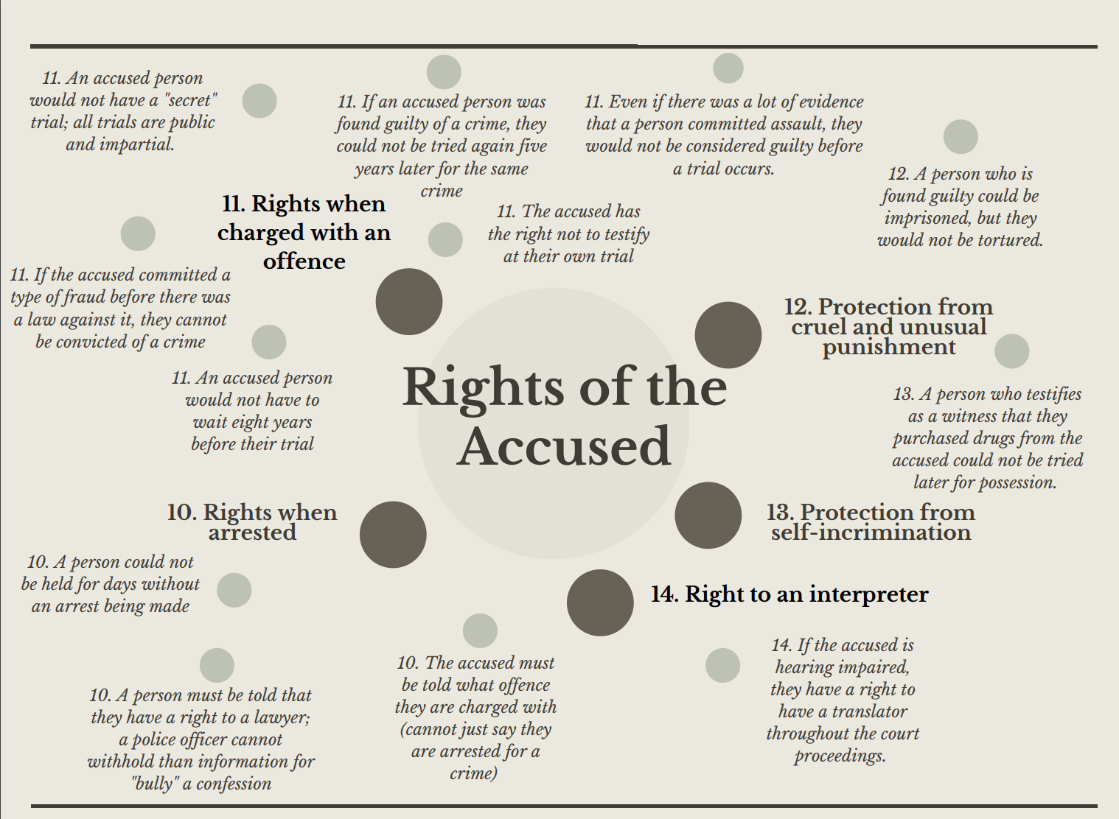

Legal Rights: Expository Essay

Instructions: Choose one of the legal rights from the Canadian Charter of Rights and Freedoms to investigate in an expository essay.

So far, we have focused on Section 10-14 of the Charter. This section of legal rights applies mainly to the rights of an accused person during trial procedures. For this assignment, you may choose any of the legal rights in the Charter of Rights and Freedom (section 7-14).

An expository essay is an essay is a type of essay that requires you to “to investigate an idea, evaluate evidence, expound on the idea, and set forth an argument concerning that idea” (“Expository Essays”). The idea you are investigating is one of the legal rights. Your essay will define the right, and evaluate how it has been applied in Canada. You can expand on that idea by discussing particular legal cases or controversies related to the legal right. Successful essays will include an argument that may analyze the significance, necessity or effect of this legal right.

For further information on the expository essay:
“Expository Essays.” Purdue Writing Lab, Purdue University, owl.purdue.edu/owl/general_writing/academic_writing/essay_writing/expository_essays.html#:~:text=The%20expository%20essay%20is%20a,a%20clear%20and%20concise%20manner.

Expository Essay Outline
Introduction Paragraph
Hook: (a first sentence to grab the reader’s attention)

Background Information
- Brief summary of the topic and key terms (legal rights, Canadian Charter of Rights and Freedoms)

Thesis:
- Identify the subject (i.e. your particular legal right)
- Set forth your argument (statement about the significance, necessity, or effect of the legal right)

Body Paragraph 1
Topic sentence:

Evidence:
Definition of the right, evaluation of how it is applied in Canada, relevant legal cases or controversies

Analysis:
Connect evidence to the argument in your thesis.

Body Paragraph 2
Topic sentence:

Evidence:
Definition of the right, evaluation of how it is applied in Canada, relevant legal cases or controversies

Analysis:
Connect evidence to the argument in your thesis.

Body Paragraph 3
Topic sentence:

Evidence:
Definition of the right, evaluation of how it is applied in Canada, relevant legal cases or controversies

Analysis:
Connect evidence to the argument in your thesis.

Conclusion Paragraph
Restate (rewrite) your thesis using different words:

Explain in 2-3 sentences why your argument is correct, referring to the evidence in your body paragraphs.

Final concluding sentence:

Legal Rights: Expository Essay Rubric

 | Minimally Meeting Expectations | Approaching Expectations | Meeting Expectations | Exceeding Expectations
Understanding | Limited understanding of the legal right is demonstrated through a detailed, clear, definition. Student minimally assesses how it has been applied in Canada. | Some understanding of the legal right is demonstrated through a detailed, clear, definition. Student somewhat assesses how it has been applied in Canada. | Solid understanding of the legal right is demonstrated through a detailed, clear, definition. Student evaluates how it has been applied in Canada. | Deep understanding of the legal right is demonstrated through a detailed, clear, definition. Student fully evaluates how it has been applied in Canada.
Argument | Missing or unclear argument; limited support by facts, examples and analysis. No thesis present. | Sets forth a simple argument supported by facts, examples, and analysis. A thesis is present but may be unclear. | Sets forth a solid argument supported by facts, examples, and analysis. A thesis is clear. | Sets forth an insightful argument supported by facts, examples, and analysis. A thesis is clearly stated.
Communication | Organization of written work is of limited effectiveness; paragraphs, topic sentences, and transitions may not be used in a way that indicates major points | Organization of written work is somewhat effective; some major points are separated into paragraphs. There are some transitions, and clear topic sentences are mostly used. | Organization of written work is effective; most major points are separated into paragraphs and signaled by topic sentences and transitions. | Organization of written work is highly effective; major points are divided into paragraphs and signaled by use of topic sentences and transitions.

