Date Reviewed
March 2021

Course
Social Studies 1

Topic
Community Roles, Rights, and Responsibilities

Big Idea
Our rights, roles, and responsibilities are important for building strong communities.

Essential Question
How do my decision affect those around me?

Learning Standards
Content
Students are expected to know the following:
- roles, rights, and responsibilities in the local community

Curricular Competencies
Students are expected to be able to do the following:
- Identify fair and unfair aspects of events, decisions, or actions in their lives and consider appropriate courses of action (ethical judgment)

Core Competencies
Communication – I can explain why communities have rules and laws.

Thinking – I can reflect on my rights and responsibilities.

Personal and Social - I can describe how my decisions impact my community.

First People’s Principles of Learning
Learning ultimately supports the well-being of the self, the family, the community, the land, the spirits, and the ancestors.

Introduction
- Read aloud or show a video of the picture book Franklin’s Neighborhood (6:33).
- Have students share things they like about their neighborhood.

Pre-Assessment
- Use a Think Pair Share strategy to have students respond to the question: What is a community?
- Record responses on chart paper. Guide students to understand that our neighbourhood and our school are examples of communities. Define “communities” as places where we live, work, learn, and play.

Interactive Learning Activities
Part 1: People and Places
- Show the video Who Am I? Community Helpers (5:11), stopping after each question to allow students to say who the community helper is.
- Ask: Who are the community helpers that make our community fun? Safe? A great place to live? Why are they important?
- Have students draw a picture of their favourite community helper and explain why they chose them.
- Point out that our community is made up of places as well as people.
- Ask: What places makes our community a great, fun, safe place to live? (Responses may include the rec centre, school, library, police station, and hospital.)
- Have students draw a picture of a favourite place in the community and explain why they chose it.

Part 2: Rules and Laws
- Explain that when people are together in a community, there are rules to keep everyone safe and happy. Rules help make things fair.
- Ask: What rules do we have at school? What rules to you have at home? (Point out that different families may have different rules.) What happens when you break a rule? (Point out that consequences for breaking rules may depend on the situation.)
- Show first 2 minutes 15 seconds of the video Rules and Laws: Exploring Communities on Harmony Square.
- Explain that rules are made and enforced by people such as parents or teachers while laws are made by the government and enforced by the police.
- Provide students with the handout “Rule or Law”. Have students work with a partner to determine if each statement is a rule or law. They can show their decision by circling either the word “rule” or the word “law”.

Part 3: Rights and Responsibilities
- Explain that children have the right to feel happy and safe at school. Define “right” as something that every person deserves, and that cannot be taken away from them.
- Read aloud or show a video of the picture book I Have the Right to be a Child (3:44).
- Have students reflect on the rights that they have as children.
- Explain that children also have responsibilities. Define “responsibility” as something that is expected of you, and that benefits everyone.
- Ask students what things they are expected to do at home, at school, and in their community.
- Provide students with the handout “My Responsibilities” and have them write or draw at least one responsibility they have in each of the following categories:
  - At home
  - At school
  - Within our community
Part 4: Decision Making:
- Read aloud or show a video of the picture book The Favorite Book (4:00).
- Explain that we have to make decisions all the time. Some are easy to make such as; Do you want ketchup on your hot dog? Some are more complicated: Would like chocolate sundae with sprinkles? Whip cream? A cherry? Marshmallows? Candies?
- Have students share a time when they had to make a decision. Ask students how they make decisions. When is it easy to make a decision? When is making a decision difficult?
- Lead a discussion about who makes decisions in different settings:
- At home (may include myself, parents, grandparents)
- At school (may include myself, teacher, education assistants, principal)
- In your city (may include mayor, grocery store manager, councillor, police, fire department, bylaw officer, park workers)
- Have students reflect on how their decisions affect their community by asking them to consider the impact of the following decisions:
- I don’t eat my snack.
- I don’t clean my bedroom.
- I wear two different socks.
- I throw my snack wrapper on the school grounds.
- I leave my backpack on the floor.
- I throw a plastic bottle in the creek.
- Will my decision affect others? the community? the environment? If so, how?
Part 5: Making Change
- Read aloud or show a video of the picture book Hey, Wall (3:10).
- Discuss the positive impact change can have in a community.
- Ask: How we make our community better?
- Take students on a walk to see what the class can do to make a positive change at the school or within the community and local environment.
- Upon return to the classroom, have students brainstorm a list of project ideas that will make a positive change in their community, such as a weekly school yard/street clean up or collecting bottles to make money for bee or bird houses.

Post-Assessment
- Provide each student with the handout “My Community”.
- Have students respond to each of the four prompts with words and images.

Extension Activities
- Show a video of the picture book Maybe Something Beautiful: How Art Transformed a Neighbourhood (7:19).
- Have each student contribute a painting to a class mural.

Additional References
Videos

Bounce Patrol - Kids Songs. 2017. “Alphabet Occupations: ABC Jobs Song for Kids.” [video]
https://www.youtube.com/watch?v=r6Oxqyd5qUw

Fuzzaboom. 2016. “Decisions Can be Hard.” Kids Puppet Show. [video]
https://www.youtube.com/watch?v=0NpQronsFic

Shoe and Friends. 2018. “Being Responsible: Responsibility Song, Kids and Toddlers.” [video]
https://www.youtube.com/watch?v=iVs5GkGYwMc

Super Kidzo TV. 2019. “Who Am I?” Community Helpers Riddle. Educational Video – Part # 2. [video]
https://www.youtube.com/watch?v=bsQx1TTe0KQ

TinyGrads. Little Mandy Manners. 2015. “Being Responsible.” [video]
https://www.youtube.com/watch?v=IzEYos5En_k

Picture Books

Rules:
Binkow, H. 2005. “Howard B. Wigglebottom Learns to Listen.” [U.S.A.]: Thunderbolt Publishing.

Javernick, E. and C.M. Madden. 2010. “What if Everybody Did That?” Tarrytown, NY: Marshall Cavendish.

Keller, L. 2009. “Do Unto Otters: A Book About Manners.” New York, NY: Henry Holt & Company.

Rathmann, P. 1995. “Officer Buckle and Gloria.: New York: G.P. Putnam's Sons.

Responsibility:
Barnett, M. 2009. “Twitters and His Blue Whale Problem.” New York: Disney/Hyperion Books.

Gravett, E. 2016. “Tidy.” London: Two Hoots.

Jeffers, O. 2017. “Here We Are: Notes for Living on Planet Earth.” London: HarperCollins Children's Books.

John, J. [2019]. “The Good Egg.” New York, NY: Harper, an imprint of Harper Collins Publishers.

Seuss, Dr. [1971]. “The Lorax.” New York: Random House.

Willems, M. 2008. “The Pigeon Wants a Puppy!” New York [N.Y.]: Hyperion Books for Children.

Willems, M. 2016. “Nanette’s Baguette.” New York, New York: Hyperion Books for Children, an imprint of Disney Book Group.

Decision Making:
McLeod, C. [2020]. “Spend It!” New York: Nancy Paulsen Books.

Seuss, Dr. 1960. “One Fish, Two Fish, Red Fish, Blue Fish.” New York, Beginner Books; distributed by Random House.

Materials and Resources

Rule or Law

Do not steal.  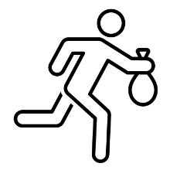  Rule or Law? | Walk in the hall.  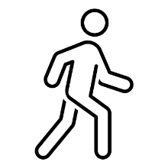  Rule or Law?
Wear a seatbelt.  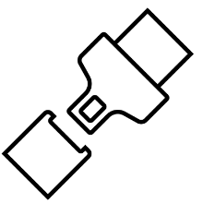  Rule or Law? | Keep your hands and feet to yourself.  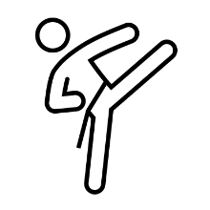  Rule or Law?
Raise your hand.  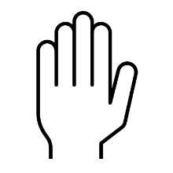  Rule or Law? | Stop at a red light.  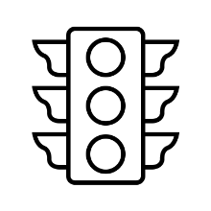  Rule or Law?

My Responsibilities

Home
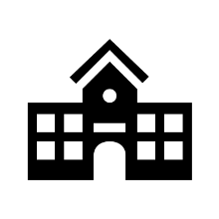 School
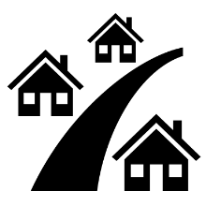 Community

My Community

I like to _________in my community. | I can help others in my community by….
My community is special because… | One thing I would like to change about my community is…

