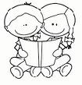
What Does it Mean to Have Empathy?

Name:

I show I care when I

